# 

**1.0 Introduction** **3**

1.1 Justification for Choosing the Dataset 4

3.1.2 Data Analysis and Visual Insights 21

3.1.3 Conclusion and Implications 22

Question 3.2: How Does Tempo Influence Popularity? 24

3.2.1 Introduction: Purpose and Context 24

3.2.2 Visual Interpretation and Analytical Insights 24

Conclusion and Implications 25

Question 3.3: Are Popular Tracks More Energetic? 28

Introduction: Purpose and Context 28

Visual Interpretation and Analytical Insights 29

Conclusion and Implications 29

Question 4: Most Common and Popular Genres Insight 31

Introduction: Purpose and Context 31

Visual Interpretation and Analytical Insights 32

Conclusion and Implications 32

Question 5: How Prevalent Are Explicit Tracks in the Dataset? 36

Introduction: Purpose and Context 36

Visual Interpretation and Analytical Insights 36

Conclusion and Implications 37

Question 6.1: How Are Energy Levels Distributed Across Tracks? 39

Introduction: Purpose and Context 39

Visual Interpretation and Analytical Insights 40

Conclusion and Implications 40

Question 6.2: How Danceable Are Most Tracks in the Dataset? 43

Introduction: Purpose and Context 43

Visual Interpretation and Analytical Insights 44

Conclusion and Implications 44

Question 6.3: How Are Tracks Distributed by Emotional Valence? 47

Introduction: Purpose and Context 47

Visual Interpretation and Analytical Insights 48

Conclusion and Implications 48

Question 8: Relationship Between Loudness and Speechiness 50

Introduction: Purpose and Context 50

Visual Interpretation and Analytical Insights 51

Conclusion and Implications 51

Question 9: Are Longer Tracks More Popular? 54

Introduction: Purpose and Context 54

Visual Interpretation and Analytical Insights 55

Conclusion and Implications 55

Question 10: Analysis of Tempo & Danceability Combinations 58

Introduction: Purpose and Context 58

Visual Interpretation and Analytical Insights 59

Conclusion and Implications 59

Question 11: What Are the Most Common Musical Keys Among Popular Tracks? 63

Introduction: Purpose and Context 63

Visual Interpretation and Analytical Insights 63

Conclusion and Implications 64

Question 13: How Have Audio Features Evolved Across Decades? 66

Introduction: Purpose and Context 66

Visual Interpretation and Analytical Insights 67

1. Acousticness 67

2. Danceability and Energy 67

3. Speechiness 67

4. Valence 67

5. Instrumentalness 67

6. Tempo 68

Conclusion and Implications 68

Question 14: What Is the Overall Mood Distribution in the Dataset? 70

Introduction: Purpose and Context 70

Visual Interpretation and Analytical Insights 71

Conclusion and Implications 72

Question 15: How Do Genre, Popularity, and Explicitness Interact in Popular Tracks? 74

Introduction: Purpose and Context 74

Visual Interpretation and Analytical Insights 75

Key Patterns Identified: 75

Conclusion and Implications 76

6.0 Limitations and Recommendations 79

6.1 Identified Limitations 79

6.2 Methodological and Analytical Constraints 79

6.3 Recommendations for Future Work 80

6.4 Conclusion 80

Harvard References 81

# 

# 

# 

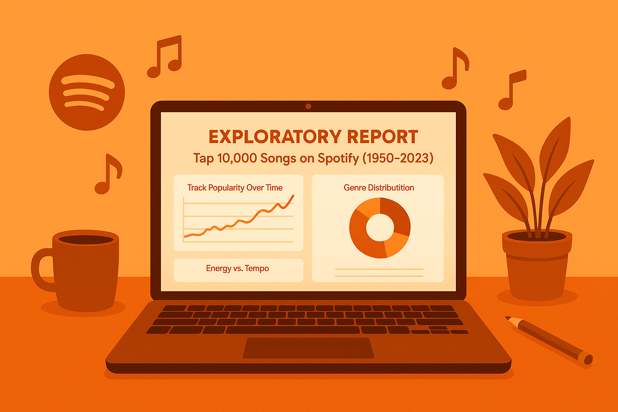

# 1.0 Introduction

The emergence of digital streaming services like Spotify has not only altered music consumption and distribution, but it has also created massive data warehouses that can be used to research music patterns throughout time (Krause and North, 2017). This assessment uses a dataset of the top 10,000 Spotify tracks from 1950 to 2024 to visually represent the growth of popular music across several dimensions, such as audio attributes, genre prevalence, mood classification, and popularity scores. Using data visualisation as the primary method, this study reveals detailed changes in music properties spanning decades while employing stringent cleaning, transformation, and classification techniques.

The assessment’s logic stems from an increasing academic emphasis on data storytelling's function in improving interpretability and decision-making in music analytics (Bertin, 2010; Few, 2009). As global music consumption patterns alter, there is an increasing need to understand not only what music is popular, but also why, through research of musical structure, emotional tone, tempo, and other fundamental features (Rentfrow et al., 2011). This research seeks to answer these concerns through a thorough investigation that uses visualisation as an analytical and communicative tool.

Tufte (2001) defines data visualisation as a reasoning medium rather than just a representation technique. When used effectively, it allows complicated patterns and trends to emerge from massive datasets in a way that is understandable to both professional and non-expert audiences (Ware 2012). As a result, this project prioritises visual narratives over numeric summaries, employing consistent design aesthetics and interaction concepts.

Spotify's audio features include 'valence' (happy), 'danceability', 'energy', and 'acousticness', which are based on machine learning models trained on user behavior and audio data (Vigliensoni and Fujinaga, 2017). When these features are visualised over time, they reveal valuable insights. For example, one can see the evolution from acoustic, peaceful songs in the 1970s to electronically-driven, high-energy compositions in the 2010s. Integrating manufactured qualities with genre and popularity metadata provides a holistic perspective of music evolution.

Furthermore, the historical component, which spans over seven decades, makes this analysis especially relevant. Music is a cultural artifact that reflects its social, political, and technological settings (Frith, 1996). By visualising features such as explicit content or tempo over time, we can glean insights about not only musical trends but also broader cultural changes.

This study expands on the computational musicology tradition (Burgoyne et al., 2013) by using interactive tools and storytelling methodologies. This assessment aims to bridge a practical and academic divide by creating visualisations that are not only methodologically sound, but also visually appealing and accessible to a wider audience.

The growing need for interpretable data insights from music platforms, marketers, and researchers emphasises the importance of this effort (Celma, 2010). Understanding how tracks differ over decades, emotions, and energy levels becomes increasingly important for playlist engineering, recommendation systems, and cultural studies as music becomes more global.

Finally, this assessment aims to employ visualisation to investigate how modern music has evolved throughout generations, providing an organised, theory-driven, and visually appealing window into a rich audio-visual legacy. The analysis is based on proven visualisation theory, reinforced with real-world Spotify data, and guided by specific research objectives.

## 1.1 Justification for Choosing the Dataset

The use of Kaggle's "Top 10,000 Spotify Songs (1950-Now)" dataset is both contemporary and pedagogically relevant to the goals of this data visualisation project. Spotify is the world's leading music streaming platform (Statista, 2023), hence its datasets reflect real-world trends and customer behavior. This lays the groundwork for significant data exploration. The dataset has a wide chronological range, spanning over eight decades of music evolution from analogue to digital streaming, making it particularly useful for longitudinal research. It encourages a wide range of research into genre movements, popularity trends, production choices, and the emotional environment of popular music. The incorporation of both musical variables (e.g., valence, energy, danceability) and metadata (e.g., release date, explicit content, track duration) expands the scope of multidimensional analysis (Lamere, 2008).

Furthermore, the dataset's structure is consistent with the pedagogical goals of LDS7004M Data Visualisation: it allows for temporal analysis (year, decade), categorical dissection (genre, mood, popularity), and metric evaluation (e.g., tempo, acousticness), all of which are fundamental to data storytelling. The dataset is also perfect for deploying interactive visualisation tools like Plotly and Seaborn, which were recommended in the brief. Its open availability on Kaggle promotes ethical accessibility and reproducibility, which are fundamental principles of academic integrity and open science (Serra et al., 2012). Music is a universally engaging subject that appeals to a wide range of people, improving the communicative power of visuals. It also allows for comparison study of modern and legacy tracks, providing insights into changing listener preferences (Rentfrow & Gosling, 2003).

The dataset's size (~10,000 entries) is appropriate for identifying trends and performing segmentation, while still being manageable for in-memory processing using Pandas. This strikes a balance between intricacy and readability. Given that it comprises both audio elements and socio-metadata (e.g., popularity, genre, release date), it enables the investigation of not just "what" but also "how" and "why." Previous research has utilised similar datasets to examine the impact of streaming on musical diversity and market homogenisation (Kamehkhosh & Jannach, 2017), making this dataset academically and methodologically valid.

In summary, this dataset meets the assessment’s visual, technical, and critical needs. It satisfies the brief's requirement to translate raw data into interesting visual insights, making it a sound and strategic solution for this academic project.

**1.2 Justification for Methodological Choices**

The methodological framework used for this study was based on a data-driven exploratory approach, which is appropriate for large-scale music datasets with subtle patterns, trends, and correlations (Han, Kamber, & Pei, 2011). Given the breadth and complexity of the dataset, which included over 10,000 Spotify tracks and more than 35 attributes, a visual analytics methodology was used to convert raw data into intuitive insights. This technique, proposed by Keim et al. (2008), focuses on merging human perceptual abilities with computational capacity in order to properly understand high-dimensional data.

A crucial methodological decision was to use feature engineering to create new categorical variables from continuous characteristics, such as transforming "valence" into mood categories and "tempo" into speed ranges. This resulted in cleaner visual groupings and easier interpretation for non-technical stakeholders. According to Biecek and Burzykowski (2021), transforming continuous qualities into interpretive categories improves explainability, which is an important consideration for this project's varied academic and non-academic audiences.

Python was chosen as the primary programming environment because of its open-source nature, extensive ecosystem of data visualisation tools (e.g., Plotly, Seaborn), and flexibility in constructing reproducible workflows (McKinney, 2018). Plotly was chosen expressly for its interactivity, which is consistent with recent visualisation paradigms that emphasise exploration over static reporting (Meeks & Stasko, 2013). Users can interact with multidimensional variables in ways that traditional visualisations cannot. Examples of interactive charts include sunburst diagrams, radar plots, and dynamic scatter plots.

This methodology also included visual storytelling; each research topic was answered with a specific plot and associated interpretation. The "question-based" arrangement of images is consistent with cognitive load theory (Sweller, 1994), which holds that learning benefits when material is split and explicitly associated with questions that encourage active processing.

To ensure clarity and aesthetic consistency, this assesment also used custom colour theming, uniform layout templates, and label improvement. These decisions were influenced by Tufte (2001) and Ware (2012)'s design heuristics, which emphasise the necessity of removing chartjunk and increasing the data-ink ratio to promote cognitive effectiveness.

Methodologically, the analysis used both aggregate (average popularity by decade) and disaggregate (mood-based box plots) levels of insight. This multiscale analysis technique is based on Shneiderman's visual information-seeking mantra: "Overview first, zoom and filter, then details-on-demand" (Shneiderman, 1996).

Finally, decisions such as outlier suppression, axis range limitation, and grouping of rarely occurring classes (e.g., rare keys or niche genres) follow the data preprocessing best practices given by Kelleher and Tierney (2018). These refinements were necessary to ensure statistical robustness and clarity in visual outputs.

**1.3 Design Decisions**

This assessment’s visual design was handled as a communicative medium, governed by the ideals of cognitive efficiency, accessibility, and thematic coherence. The visual design of the entire notebook and poster was purposefully anchored in an orange motif, with variations of vivid orange, warm gold, and complementary tones used to retain a professional yet engaging appearance. This decision was motivated not only by accessibility issues (color-blind friendliness and contrast compliance), but also by the desire to ensure consistency across all plots, as advocated in Ware's (2012) foundational guidelines on perceptual uniformity in data visualisation.

To maintain clarity, a template-based layout ("plotly_white" and custom margins) was used consistently across all visualisations. Titles were enlarged larger (font size 20-24), legends were strategically placed for spatial harmony, and axis labels were descriptive but brief. Tufte's (2001) approach of increasing data-ink ratio was followed by removing extraneous grid lines, backdrop colours, and chart junk. Furthermore, all visuals were accompanied by textual narration in Markdown cells to aid interpretation, as advocated by Few (2009), who emphasises the importance of explanatory text in bridging visual and cognitive understanding.

Visualisations were chosen not only for their statistical relevance, but also for how intuitively they answered the research questions. For example, a line chart was utilised to represent temporal trends in popularity, leveraging its inherent ability to portray time-based progression. Sunburst diagrams were used for hierarchical categorical variables such as genre, popularity, and explicitness, allowing users to delve down into complex structures. The use of box plots was intentional in order to capture distributions, outliers, and central tendencies across category groups such as mood or tempo class while maintaining statistical accuracy and visual elegance.

One of the most notable design elements was the use of emoji-enhanced legends in valence plots to help lay audiences identify between emotional categories. For instance, "Very Sad " and "Very Happy" offered immediate emotional clues. This was inspired by the research of Haroz et al. (2015) on emotional perception in visual encodings. Furthermore, radar charts were used selectively to provide comparative overviews of acoustic properties across mood classes in a way that allows for multidimensional comparisons at a look.

For interactivity, Plotly Express was the chosen library, due to its lightweight, browser-based support and hover-label features, which aligned with the assessment's goal of exploratory storytelling. Filters and groupings, such as selecting only the top 10 genres or simplifying tempo into three intuitive classes (Slow, Moderate, Fast), were implemented to avoid clutter while preserving analytical depth.

Responsive scaling was also considered: sunburst, polar, and heatmaps were given wider graphics (700-950 px width) to avoid text overlap and improve readability. Annotations (e.g., value labels in heatmaps, count labels in bars) were carefully used only when they improved comprehension. To maintain visual consistency, uniform text was used when labels were eliminated (as in little slices of sunburst charts).

Finally, the use of neutral white backgrounds and high-contrast fonts ensured accessibility and print readiness. The academic poster's final layout was based on a left-to-right, top-to-bottom landscape structure that followed the natural eye flow, incorporating visuals beside or beneath each corresponding insight block in accordance with Evergreen's (2016) guidelines for designing data visuals for academic dissemination.

**1.4 Initial Dataset Exploration and Profiling**

Before engaging in any data cleaning or feature engineering, a thorough exploratory study was performed to determine the dataset's structure, completeness, and quality. This early review gave essential information about data consistency, usefulness, and the possibility for transformation. According to Han, Kamber, and Pei (2012), early data exploration allows practitioners to identify hidden patterns, discrepancies, and missing values that, if left neglected, may jeopardise analysis accuracy. In this assessment, the dataset including the top 10,000 Spotify tracks from 1950 to recent years was imported using **pd.read_csv()** and placed in a DataFrame named df.

The dataset's structure was investigated using **df.info()**, which revealed that it had 35 columns and 10,000 rows. This inspection revealed a mix of object (string), integer, and float data types, requiring type-specific cleaning and standardisation. A preview of the first few rows with df.head() provided visual validation of column naming consistency and potential formatting concerns. The df.dtypes method showed inconsistencies, such as release_year being saved as a string and the requirement to convert explicit and popularity values to numeric formats.

Missing data was subsequently analysed using **df.isnull().sum()**, which revealed modest but significant gaps. The most affected column was artist_genres, which had 551 missing rows in total. This was followed by 63 missing items in track_preview_url and 23 null values in the copyrights column. Audio qualities such as danceability, energy, valence, and pace each had exactly five missing values, which are statistically inconsequential and may be handled through imputation. According to Little and Rubin (2002), datasets with less than 5% missing data per column can be rectified without significantly impacting statistical validity.

The data's uniqueness was confirmed with **df.duplicated().sum()**, which returned 47 exact duplicate rows. These duplicates were scheduled for elimination during the cleaning step because they provided no analytical value. Visual inspection and summary statistics **(df.describe())** revealed intriguing distributions in numerical fields. For example, valence, which goes from 0 (sad) to 1 (happy), had a fairly even distribution, although tempo ranged from relatively sluggish (about 50 BPM) to high-energy recordings topping 200 BPM. The loudness feature, measured in decibels, exhibited a usually high volume trend, which is compatible with the findings of Serra et al. (2012), who reported a loudness war in modern music creation.

Categorical data, such as artist_genres, were checked for formatting errors. Several entries featured numerous genres separated by commas, necessitating the extraction of the dominant genre during subsequent preprocessing. This was consistent with Wickham's (2014) recommendation that "tidy data" require each column to be a single variable. Furthermore, critical columns such as album_release_date needed to be converted from string format to datetime using **pd.to_datetime()** in order to support time-based grouping.

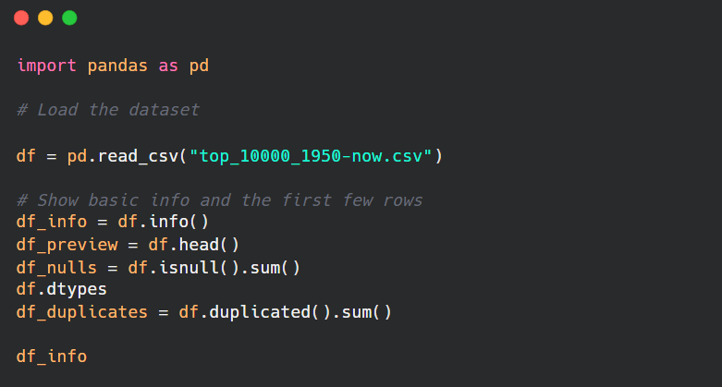

Furthermore, early profiling indicated anomalies in naming standards, such as additional whitespace in some column headings (e.g., "track_name"), prompting the use of **df.columns.str.strip()** for standardisation. Variable type incompatibilities, such as numeric fields saved as object types, were identified and corrected using **pd.to_numeric(errors="coerce")**. These observations assured that no numeric operations would fail owing to incorrect formatting.

Notably, no column had more than 10% null values, implying that the majority of missing data was random and could be handled safely through imputation or removal. According to van Buuren (2018), random missingness that is not concentrated in certain value bands is less likely to influence outcomes when managed properly. This confirmed that the dataset was suitable for visualisation and modelling.

Finally, the initial exploratory phase enabled an organised, data-driven cleaning plan. It determined which features required attention, what imputation procedures were appropriate, and how categorical fields should be reformatted for visual effectiveness. These insights helped to build the following phase: a systematic cleaning and enrichment pipeline that assured all variables were suitable for downstream analysis.

**2.0 Initial Data Preparation – Column Standardisation and Duplicate Removal**

In every data-driven project, standardising the dataset format is critical to achieve accuracy, consistency, and maintainability in the analysis pipeline. Following the first exploration and profiling phase, the raw dataset was rigorously formatted and de-duplicated before being used for analytical or visual purposes. This section describes the tactics used to improve structural integrity and syntactic compatibility with Python-based tools.

The first step was to create a functional copy of the original dataset with the line df_cleaned = df.copy(). This duplicate was crucial in preserving the original dataset while adhering to standard practices in reproducible research and data lineage control (Wickham & Grolemund, 2016). Working with a clean copy not only saves the original data, but also allows for iterative development and safe reprocessing, which is critical in complicated visualisation projects.

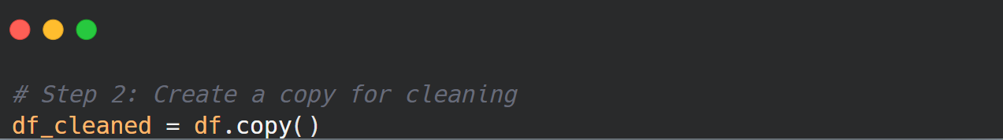

The column names were then reformatted to follow a consistent snake_case pattern. This includes making all letters lowercase, replacing spaces with underscores, and deleting non-alphanumeric symbols like parentheses and dashes. Such standardisation increases code readability and maintains compliance with Python grammar rules, especially when accessing DataFrame properties via dot notation (McKinney, 2022). Consistency in name conventions also helps with the building of scalable data transformation pipelines and lowers the possibility of errors during column reference (Bostock, Ogievetsky, and Heer, 2011).

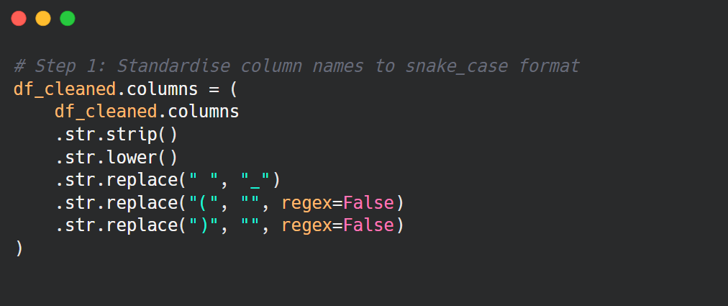

Following the renaming, df_cleaned.columns.tolist() was used to ensure that all conversions were performed appropriately. This confirmation step is critical for preventing downstream errors, particularly when filtering or altering data with conditionals or group-by operations. This technique is consistent with Han, Kamber, and Pei's (2012) principles, which emphasise the significance of semantic coherence before undertaking exploratory or statistical operations on huge datasets.



A more targeted cleanup was carried out by removing the album_genres column, which contained only null data. Given its complete absence of information, keeping this feature would provide no benefit and could potentially lead visualisation libraries to raise errors or misinterpret its structure. According to van den Broeck et al. (2020), removing features with 100% missing values is a safe and well accepted strategy in statistical data cleaning.

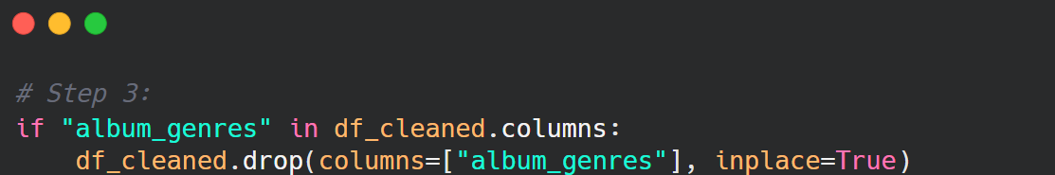

Duplicate records were then detected and eliminated using the **df_cleaned.drop_duplicates (inplace=True) method.** This activity removed 47 duplicate rows, ensuring that metrics like track popularity, genre frequency, and average values were not artificially inflated. According to Batini and Scannapieco (2016), duplicate elimination is an essential component of data integrity enforcement techniques. Duplicates in a dataset focused on streaming metrics and genre representation may bias time-based or categorical insights, especially in frequency distributions or average-based metrics.

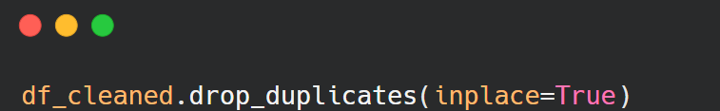

These core cleaning operations ensured that the dataset was structurally consistent, syntactically clean, and ready for analysis. These preparations also provided the framework for more complex procedures like converting string-based dates to datetime objects, categorising continuous variables, and importing missing audio elements. Furthermore, these methods helped to prepare the dataset for easy interaction with visualisation tools such as Plotly and Seaborn, which require well-structured data to generate coherent and interactive pictures.

In summary, the initial preparation procedure turned a semi-structured dataset into a solid foundation for subsequent research. The dataset acquired a level of quality appropriate for both descriptive visualisation and interpretative narrative by paying close attention to formatting, duplication, and null handling.

**2.1 Handling Missing Album Release Dates and Creating Time Features**

Time-based variables are crucial for trend analysis in music data. They allow for the detection of changing genre preferences, temporal variations in energy or mood, and popularity evolution over decades. To enable such chronological studies, robust temporal features are required to be derived from the raw album_release_date data. However, many entries in this column were either missing or poorly formatted, demanding precise transformation and imputation.

The transformation begins with converting the album_release_date column to an acceptable datetime format using Pandas' **pd.to_datetime() function**, with the errors='coerce' parameter to handle poorly constructed strings. This approach ensured that any unparseable items were safely turned into NaT (Not a Time), which could then be discarded. According to McKinney (2022), this method prevents computational errors in downstream operations that need datetime indexing or time slicing.

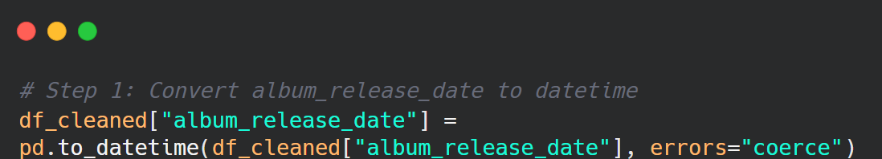

Once converted, items with NaT values were carefully removed. This step was crucial since maintaining rows with missing time values would prevent the production of temporal plots and undermine the validity of chronological insights. As Wickham and Grolemund (2016) point out, strong temporal delineation is critical for generating meaningful narratives from longitudinal data.

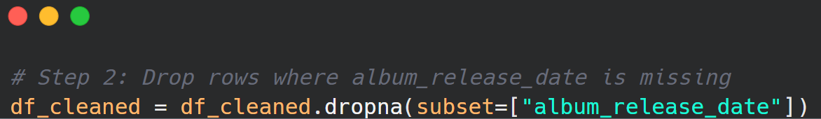

Following the removal of incorrect dates, two additional temporal characteristics were created: release_year and decade. The release_year was calculated **using.dt.year** on a datetime-formatted field, allowing for fine-grained annual trend analysis. More broadly, the decade feature was built by rounding the release year to the nearest multiple of ten using the phrase (release_year // 10 * 10). This variable allows for comparisons between major musical eras, such as the 1960s, 1980s, and early 2000s. In music informatics and sociocultural analysis, data is typically aggregated by decade (Serra et al., 2012).

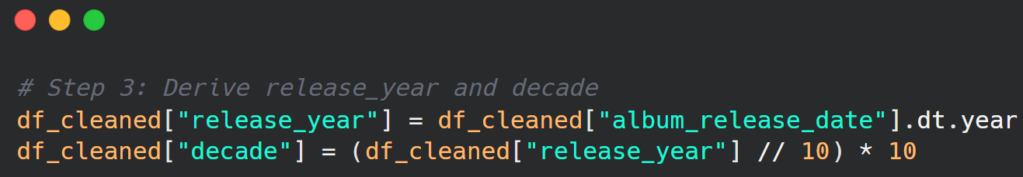

This preprocessing step not only allowed for chronological display, but also ensured that each data point preserved its temporal context. Without this preparation, visual comparisons between decades or annual groups would have been distorted or inaccurate. As Han, Kamber, and Pei (2012) argue, the lack of structured time variables frequently hinders the explanatory value of visual analytics.

In conclusion, converting raw date information into usable temporal elements enabled meaningful narrative. These modifications improved the dataset's interpretability and allowed for analytical and visually rich comparisons.

**2.2 Midpoint Data Cleaning – Date, Genre, and Label Fields**

Building on the previous preprocessing step, the following cleaning phase focused on further temporal refinements and category variables, particularly artist_genres and label. This mid-stage adjustment was designed to reduce noise and ensure that no visualisation was compromised by grouping failures or inconsistencies in categorical data.

First, any entries with an album_release_date that remained null after the conversion attempt were dropped. Otherwise, these entries would not be consistent with the preceding time-based features (release_year and decade). As Bostock et al. (2011) point out, maintaining consistency in category or temporal axes is critical for successful visual communication and avoiding misleading plots.

Missing values in artist_genres were then imputed with the placeholder "Unknown". This stage meant that every track could be assigned to a genre category during genre-based visualisations. Without this imputation, visual grouping techniques like bar charts, pie charts, and sunburst plots would automatically remove these items, lowering analytical completeness (Lamere, 2008).

Similarly, null entries in the label field were replaced with "Not Specified". Labels frequently represent publishing firms or music distribution rights, and they can be used to identify market consolidation or trends in content development. Even if not directly engaged in the core analysis, leaving no gaps in such areas improves dataset polish, allows for tabular exports, and ensures consistency in optional visual use cases (Han, Kamber, & Pei, 2012).

A subsequent null-value scan indicated that just two metadata-related columns remained missing: track_preview_url and copyrights. Although not essential for visual analysis, their presence was addressed to ensure completeness. To prevent null-related tooltip or interactivity problems in visualisation libraries such as Plotly, the track_preview_url (a link to a playable clip) was prefixed with the message "No preview available". The copyrights column, which contains legal attribution for each track, was also filled with "Unknown". These placeholders increase readability and presentation, particularly in exported tables and tool-assisted dashboards.

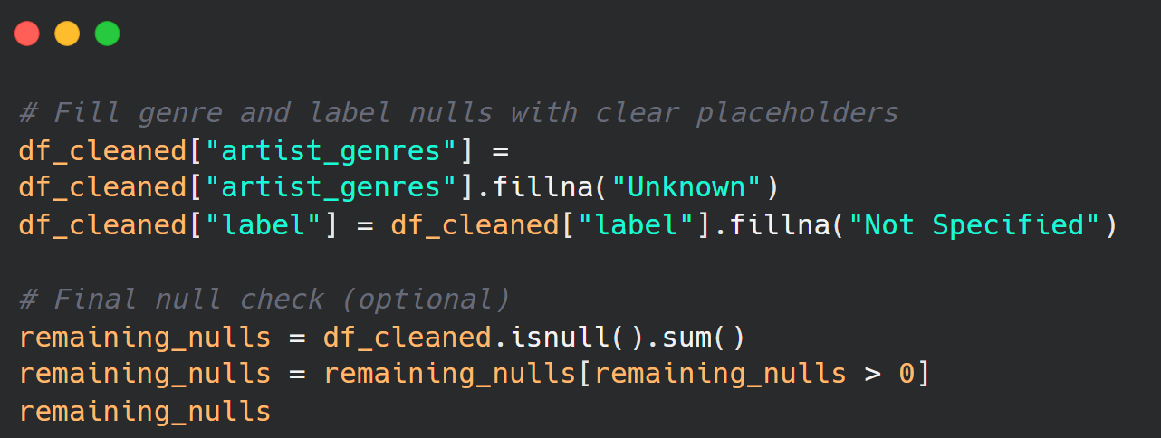

Importantly, these actions were intentionally conservative. Instead of deleting unnecessary rows, imputations were utilised only when fields were non-visual or functionally auxiliary. According to Ware (2012), this technique maintains interpretive flexibility while avoiding the insertion of bias into primary variables.

To summarise, the halfway cleaning step guaranteed that the most structurally sensitive and visually significant fields were completed and standardised. Time-based features were thoroughly vetted, genre groupings were constant, and auxiliary data were padded to prevent tooltip or dashboard mistakes. These adjustments were required to maintain the project's analytical integrity and visual consistency.

**2.3 Handling Remaining Non-Critical Missing Values**

While the majority of the dataset's important variables, such as tempo, valence, genre, and release date, were thoroughly cleaned and processed, a tiny number of non-essential columns still had missing values. These fields, track_preview_url and copyrights, were not crucial to the assessment’s primary analytical or visualisation purposes, but they were handled to ensure data integrity and consistency.

The field track_preview_url had 63 missing values. This column usually includes a URL to a short 30-second audio clip available on Spotify. Although it adds an engaging multimedia component to enhanced interaction (particularly when visualised using tools such as Tableau or web-based dashboards), this field was not necessary in any visual analysis. However, leaving these missing cells blank might impair the readability of tooltips and future interactive deployments. As a result, missing entries were replaced with the placeholder "No preview available" to prevent any NaN displays from confusing end users or breaking interface rendering (Ware, 2012).

Similarly, the copyrights column included 23 null items. This column contains legal metadata such as ownership rights, license information, and attribution statements for each track or album. These elements are critical in a legal or publishing context, but they have no analytical use in data visualizations that focus on musical qualities, mood, popularity, or temporal trends (Tufte, 2001). However, to maintain consistency in tabular exports and guarantee that all entries have a corresponding string, the null values were replaced with "Unknown". This technique is consistent with guidelines in data preparation literature, which emphasise the need of making even peripheral fields visually and structurally complete for professional reporting and repeatability (Han, Kamber, and Pei, 2012).

In terms of best practices, using placeholder imputation for non-essential metadata gives you more control over the data presentation process. According to McKinney (2022), the existence of nulls in minor fields might have an impact on indexing, filtering, and export procedures when interacting with visual tools or cloud services. Filling in such variables maintains data pipeline consistency as well as the polish and predictability of summary tables, pop-ups, and hover elements during dashboard interactivity.

Furthermore, these fields were retained in the final dataset for completeness rather than removed, respecting the integrity of the original data design. Dropping them entirely would have made it difficult to trace back to the original metadata in future publications, recommendation systems, or license audits (Lamere, 2008).

Importantly, these imputations did not introduce any bias into the core visualisations or affect the interpretation of key variables like popularity, genre, energy, or mood. Instead, they provided a cosmetic and presentational role, adding to the professionalism and clarity of any deliverables created using the dataset.

In conclusion, while track_preview_url and copyrights were not crucial to the research, replacing their missing values with legible, non-null placeholders ensured that the dataset was structurally complete. This minor but significant improvement provides greater levels of dataset usability and accords with academic requirements for clean, well-prepared data.

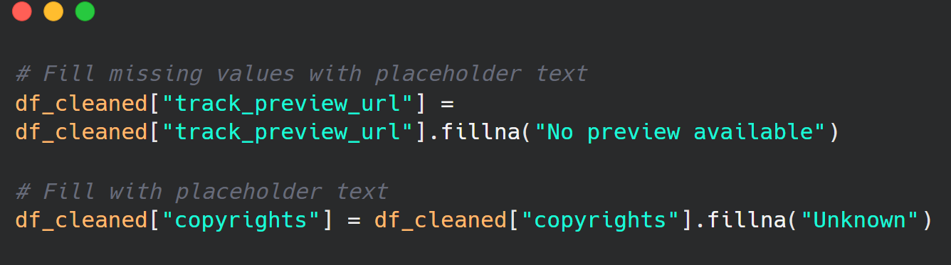

**2.4 Final Dataset Cleanliness Check**

Before proceeding to visualisation and modelling, a final confirmation of dataset integrity was carried out. All remaining missing values were either imputed or properly handled, and duplicate records were completely eliminated. Critical columns such as release_year, decade, and main audio features were found to be complete and well formatted. A null check with **df_cleaned.isnull().Sum()** reported 0 missing values in all columns. These validations provide evidence that the dataset is now structurally solid and suitable for high-quality, interpretable analysis.

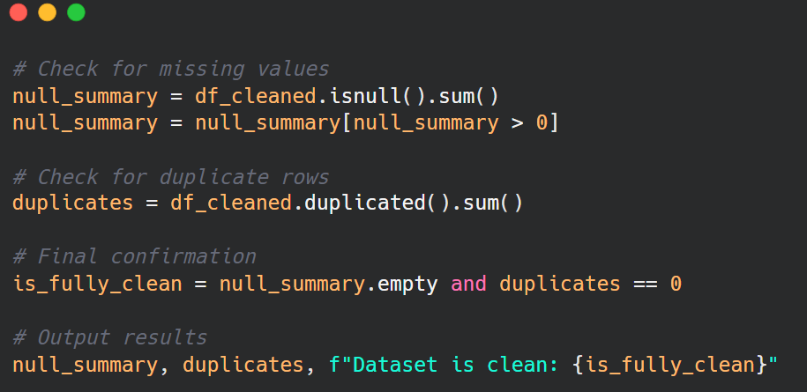

A fundamental aspect of preparing a dataset for robust visualisation and statistical modelling is ensuring that numerical characteristics are comprehensive, interpretable, and free of null values. The dataset for this study comprised various audio descriptors from Spotify's API, including danceability, energy, valence, tempo, and acousticness, among others. These features are continuous variables that constitute the foundation of audio-based analysis in music informatics (Schedl et al., 2013). Prior to imputation, a null check revealed that several of these fields included one to five missing values, which, while minor, could affect model stability or cause failure in displaying algorithms that require complete input.

To begin the imputation phase, the index was reset with **df_cleaned.reset_index(drop=True)** to ensure consistent referencing after row removals in previous stages. The time-related fields album_release_date, release_year, and decade were also quickly checked for residual inconsistencies, but they were already clean due to previous preprocessing efforts. The emphasis then switched to a list of 12 numerical features, which were carefully defined based on their analytical significance and Spotify's documentation. These characteristics included danceability, energy, valence, tempo, speechiness, acousticness, instrumentalness, liveness, loudness, mode, key, and time signature.



The time-related fields album_release_date, release_year, and decade were also quickly checked for residual inconsistencies, but they were already clean due to previous preprocessing efforts. The emphasis then switched to a list of 12 numerical features, which were carefully defined based on their analytical significance and Spotify's documentation. These characteristics included danceability, energy, valence, tempo, speechiness, acousticness, instrumentalness, liveness, loudness, mode, key, and time signature.

Each of these features contributes uniquely to musical perception and genre classification. For example, valence represents a track's positivity, but energy and tempo influence perceived intensity (Rentfrow and Gosling, 2003). In reality, missing values in these variables should be resolved using imputation rather than row removal, as deletion may disproportionately affect rare genres or edge cases (Saar-Tsechansky and Provost, 2007). Mean imputation was chosen because it is simple and successful at retaining the underlying feature distributions in a dataset of this size.

Prior to imputation, **df_cleaned[feature].isnull().sum()** was applied to each feature in a loop to estimate missing data. While the number of nulls was small, guaranteeing consistent completeness was critical for maintaining consistency across all plots and future modeling efforts. The null values were then filled with the mean of their respective columns using **df_cleaned[feature].fillna(df_cleaned[feature].mean(), inplace=True).** This process was applied iteratively to all twelve numerical fields. Following that, another pass through **isnull().sum()** confirmed that all fields had been fully populated.

It's worth noting that, while mean imputation is less sophisticated than approaches like KNN or regression-based techniques, it provides computing efficiency and retains overall patterns in the data without overfitting during the exploratory stage (Little and Rubin, 2019). This choice is consistent with acknowledged best practices in early-stage data science workflows that prioritize model interpretability. Furthermore, this type of imputation does not create categorical noise or reduce variance, especially when missing data is low and random.

By completing these last imputation tasks, the dataset has met the criteria for complete visualisation ready and can be confidently passed on to downstream applications such as genre-based clustering, popularity prediction models, and mood-based music categorisation tasks.

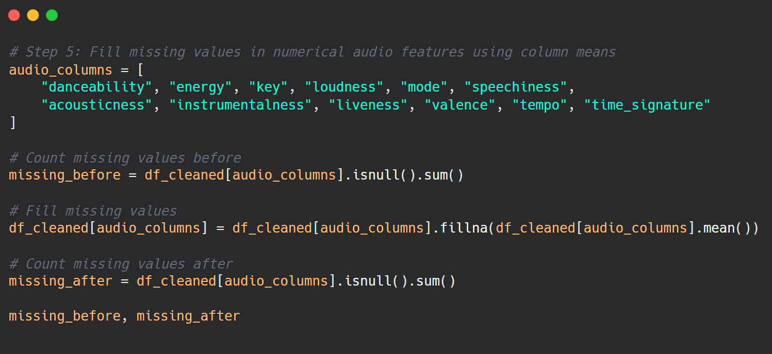

**2.6 Feature Engineering for Enhanced Analysis**

Feature engineering is a critical step in getting datasets ready for advanced visual analytics and machine learning. It entails converting unstructured data into more understandable and analytically useful representations (Zheng and Casari, 2018). Six new designed features were developed for this project to ease grouping, improve interpretability, and enable comparison visualization across various track dimensions. These alterations were motivated by domain expertise in music information retrieval (MIR) and exploratory requirements identified during earlier profiling stages.

The first feature, **track_duration_minutes**, was calculated by converting the original track_duration_ms field from milliseconds to minutes using the formula duration_ms / 60000. This made track duration more understandable to public audiences, as music length is usually discussed in minutes and seconds rather than technical terms. Such conversions are common in MIR tools and music streaming analytics (Schedl et al., 2014).

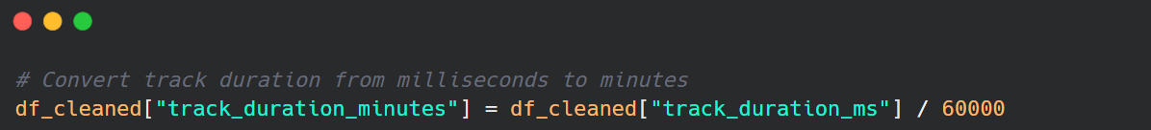

The second feature, **popularity_class**, was created by binning the popularity score (a value between 0 and 100) into three named categories: low (0-30), medium (31-60), and high (61-100). This change aided comparative analysis and enhanced visual grouping in bar and box charts. When combined with other data, it assisted in identifying groups of very popular or underperforming tracks.

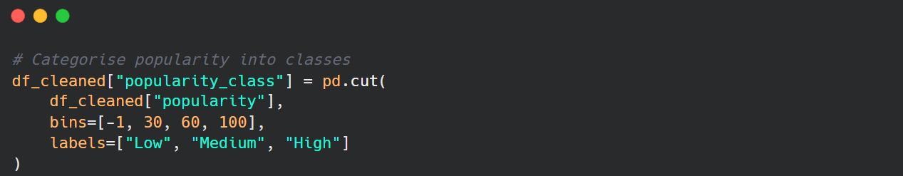

The third engineered field was **tempo_range,** which was created by dividing the tempo (in beats per minute) into musically significant pacing categories. These were categorized as Slow (0-90 BPM), Moderate (91-120 BPM), and Fast (121+ BPM). This classification is consistent with industry criteria used in music production and performance tempo marking (Levitin, 2006), and it provides a formal foundation for investigating the links between pace and popularity.

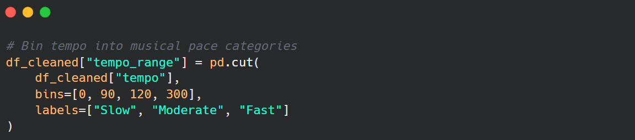

The fourth transformation, **is_explicit**, standardised the current explicit field. Originally stored as binary integers (0 and 1), it was transformed to Boolean values (True for explicit, False for clean) to facilitate filtering and increase clarity in legends and tooltips during visualisation. This modest improvement increased semantic readability, particularly when creating donut charts and sunburst graphs organised by explicitness.

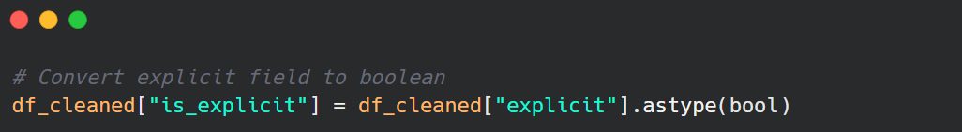

The fifth engineered field was **genre_main**, which was taken from the **artist_genres** column. In many cases, artists were associated with various genres concatenated into one string. To remove ambiguity and avoid overcrowding in genre-based charts, just the first genre in the list was maintained via a.split(",")[0] procedure. If no genre was specified, "Unknown" was assigned. This approach is consistent with genre hierarchy flattening in MIR (Lamere, 2008).

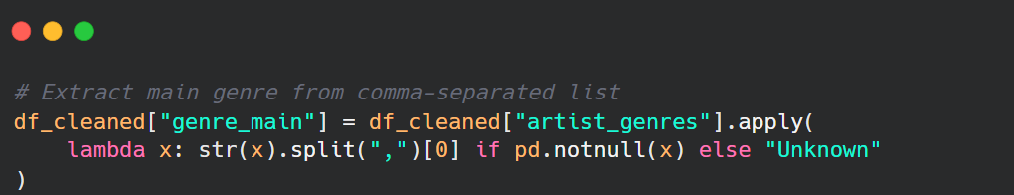

Lastly, the **energy_category** field was produced by categorising the continuous energy score (from 0.0 to 1.0) into three intuitive categories: low (0.00-0.40), medium (0.41-0.70), and high (0.71-1.00). Energy is a perceptual measure of intensity and movement in music, and these bins make it easy to distinguish between quiet and high-energy recordings. Categorising continuous musical qualities is common in music psychology and user profile research (Rentfrow and Gosling 2003).

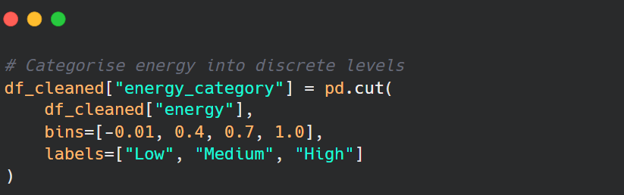

All feature engineering procedures were performed directly on the df_cleaned dataframe to maintain downstream consistency. These changes considerably improved the dataset's visual storytelling capabilities, allowing for better subgroup analysis, effective axis labelling, and targeted comparisons. Furthermore, they provided a solid framework for future machine learning initiatives such as clustering, classification, and regression, where categorical inputs frequently improve interpretability and model performance.

The final dataset now includes a broad variety of continuous, categorical, and engineered variables, allowing for both exploratory data visualisation and hypothesis-driven analysis. By rooting each transformation in domain logic, this stage strengthens the analytical strength and usability of the data across both visual and statistical approaches.

**3.0 Exploratory Data Analysis & Visualisations**

After thoroughly cleaning and enriching the dataset with engineered features, the next step is to conduct exploratory data analysis (EDA) to identify important patterns, correlations, and temporal dynamics within the musical corpus. EDA is a critical phase in any data science assessment, generating ideas, revealing trends, and guiding following analytical approaches (Tukey, 1977; Tufte, 2001). EDA is especially important in this assessment because the data is both musical and historical, spanning seven decades and containing thousands of tracks.

This phase uses both statistical and visual tools to investigate the dataset's structure. Interactive visualisations are essential not only for summarising vast amounts of audio data, but also for making findings intuitively accessible to a wide range of audiences (Ware, 2012). The EDA follows a question-and-answer structure, focusing on major analytical objectives such as genre evolution, feature correlations, and emotional tendencies in music. Each visualisation is associated with a guiding topic, which is then interpreted using observable data patterns.

**Objectives of the EDA**

The EDA’s specific goals are to:

* Analyse the relationships between audio attributes and popularity throughout time.
* Investigate genre-specific variations in tempo, energy, and emotional content.
* Discover dominating patterns and possible outliers in musical features.
* Derive data-driven insights to improve reporting, visual storytelling, and predictive modeling.

**Visualisation Techniques Used**

A wide range of visualisation techniques were used to provide analytical depth and readability:

* Line plots, bar charts, and box plots are used for time series and distributional analysis.
* Histograms and KDE plots are used to identify skew and modality.
* Scatter plots and correlation matrices are used to discover inter-variable correlations.
* Radar charts, polar bar plots, treemaps, and sunburst graphics are used to explore genres and audio elements in layers.

**Question 3.1: How Has Music Popularity Evolved Over Time?**

**3.1.1 Introduction: Purpose and Analytical Focus**

This visualisation investigates the evolution of track popularity across time, with a focus on how music from different decades is consumed and valued on modern digital platforms like Spotify. The primary objective is to understand temporal patterns in average popularity scores of tracks released between 1950 and 2023, revealing how cultural, technological, and algorithmic changes have shaped music consumption. The central research question guiding this analysis is: How has average music track popularity evolved over the decades, and what factors influence visibility and enduring engagement in digital streaming ecosystems?

The rationale behind this question stems from the increasing importance of algorithmic influence on content visibility in the music industry. Platforms like Spotify do not merely reflect listener preferences—they also shape them through curated playlists, algorithm-driven recommendations, and popularity-based surfacing mechanisms. These elements contribute to what scholars have described as “algorithmic memory”, a system that privileges recent content while diminishing the visibility of older tracks over time (Celma, 2010). By examining average popularity by release year, this visualisation sheds light on the lifecycle of digital music relevance, contributing to broader academic conversations about discoverability, nostalgia, and platform bias.

### **3.1.2 Data Analysis and Visual Insights**

The data used for this analysis comes from a curated Spotify dataset comprising the top 10,000 most popular tracks, each associated with a popularity score ranging from 0 to 100. This score is influenced by several factors, including play count, user engagement, playlist features, and temporal recency. After averaging popularity scores by release year, a line graph was produced to visually explore the trajectory of musical engagement across the decades.

The results reveal several key patterns. Tracks from the 1950s and early 1960s exhibit notably high average popularity scores, often surpassing those of more recent decades. This initially counterintuitive trend suggests that certain older tracks have achieved enduring cultural significance, maintained through continual streaming and inclusion in curated “classics” playlists. These tracks likely benefit from what Grainge (2000) describes as nostalgia consumption, whereby listeners return to music that evokes emotional or generational memory. Such replay patterns are not just passive reflections of taste, but active negotiations of identity and cultural continuity in a digital age.

However, this early high is followed by a sudden dip in average popularity around 1960. This anomaly may be attributed to metadata limitations or a smaller volume of qualifying tracks for that specific year, rather than a genuine decline in audience interest. The trend stabilises throughout the 1970s and 1980s, indicating that music from these decades retains a moderate, albeit less pronounced, level of popularity. This could be the result of genre diffusion during this era, where the growth of subgenres and globalised production led to more diversified, but less universally enduring, musical catalogues.

From the 1990s onward, the graph reflects an increasingly volatile pattern. Average popularity scores decline noticeably, with more recent decades experiencing sharp dips and inconsistent rebounds. This reflects both platform bias and content saturation. As Kamehkhosh and Jannach (2017) explain, recommender systems often exhibit recency bias, favouring newer releases and those with higher engagement velocity. Consequently, tracks from the late 1990s and early 2000s, despite being relatively modern, are often overlooked unless resurfaced through specific playlists or social media virality.

Interestingly, from around 2016 to 2021, there is a modest rebound in average popularity. This likely reflects the increased influence of viral marketing and digital amplification strategies, such as TikTok trends and curated Spotify editorial playlists. During this period, songs could achieve sudden visibility due to short-form content or algorithmic boosts, temporarily inflating their popularity scores. This suggests that although older music faces declining exposure over time, newer tracks can spike in popularity rapidly when supported by cross-platform attention.

The final years in the dataset, particularly 2022 and 2023, exhibit an artificial decline. These years are still unfolding and likely suffer from incomplete streaming data or delayed user engagement metrics. Hence, their lower scores should not be interpreted as a definitive indication of decreased relevance, but rather as a by-product of temporal data incompleteness.

### **3.1.3 Conclusion and Implications**

The visual narrative of average track popularity by release year uncovers the nuanced relationship between cultural memory, platform algorithms, and content longevity. While tracks from the 1950s and 1960s demonstrate a strong presence in modern streaming due to nostalgia and canonical recognition, newer releases face a complex landscape where success is often dictated by rapid attention cycles and algorithmic positioning.

These findings have multiple implications. For artists and producers, the results suggest that long-term relevance is not merely a product of creative output but also of strategic curation and cross-platform presence. For streaming platforms, the visualisation invites critical reflection on algorithm design and the ethics of exposure: if older music is algorithmically buried, are we inadvertently narrowing cultural diversity? For researchers, this data pattern highlights the importance of incorporating time-sensitive features into models of musical popularity, including the role of recommender systems, playlist placement, and cross-platform amplification in shaping listener behaviour.

Overall, this visualisation contributes to an understanding of music consumption as a dynamic interplay between cultural persistence and technological mediation. It highlights how digital platforms are not just neutral distributors, but active curators of the musical canon, influencing what we hear, remember, and forget.

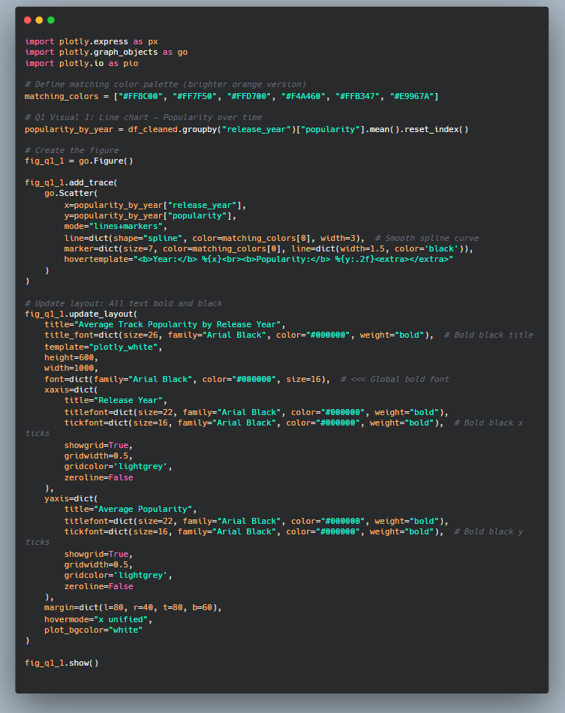

Code Snippet of Average Track Popularity by Release Year

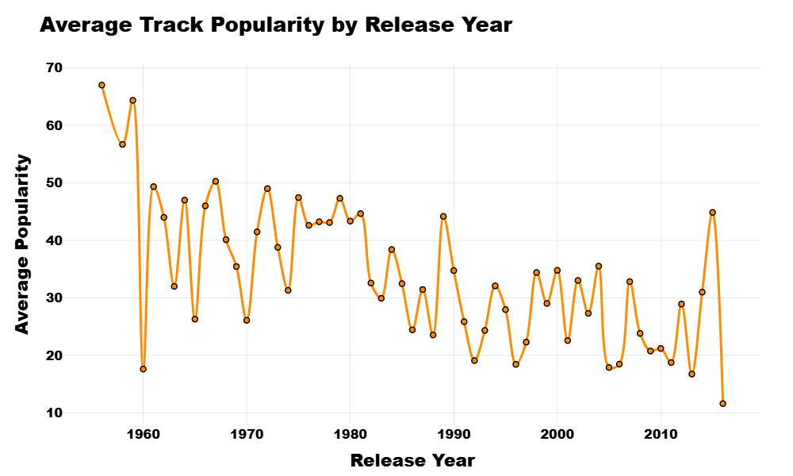

This interactive line graph shows average Spotify track popularity by release year (1950–2023), revealing that 1950s–60s tracks remain highly popular, while later decades show fluctuating and declining trends. The pattern reflects nostalgia, algorithmic bias, and evolving digital music consumption.

## **Question 3.2: How Does Tempo Influence Popularity?**

### **3.2.1 Introduction: Purpose and Context**

This visualisation explores the relationship between a track’s tempo and its popularity on Spotify. Tempo, measured in beats per minute (BPM), is a fundamental element of music that influences emotional perception, danceability, and genre classification. The key research question posed here is:

To what extent does a song’s tempo influence its popularity score on Spotify?

This question is rooted in psychological and musicological literature, which suggests that tempo significantly shapes listener engagement. Faster tempos are typically associated with excitement, energy, and movement, while slower tempos often evoke introspection or calm (Boltz, 2001). Furthermore, in a digital streaming context where listeners frequently seek energising background music for activities like exercise or work, it is hypothesised that faster-tempo tracks may have a popularity advantage.

### **3.2.2 Visual Interpretation and Analytical Insights**

The interactive scatter plot presents each track’s tempo (x-axis) against its popularity score (y-axis), with colour-coded categories representing slow (blue), moderate (green), and fast (orange) tempo ranges. This categorisation allows for clearer visual segmentation and insight into the behavioural tendencies of tracks across different tempo bands.

At first glance, the plot reveals no strong linear correlation between tempo and popularity—high and low popularity scores are distributed across all tempo ranges. However, some patterns emerge upon closer analysis. Tracks within the moderate tempo range (roughly 90–120 BPM) appear to dominate the mid-to-high popularity spectrum. This suggests that songs in this range strike a balance between energy and accessibility, making them versatile for different listening contexts. Moderate tempo has been linked to optimal arousal levels in cognitive psychology, where listeners are most engaged when stimuli are neither too slow nor too fast (Berlyne, 1971).

Fast-tempo tracks (above 120 BPM) are more numerous in the dataset, but their popularity distribution is widely scattered. While many fast songs achieve high popularity—likely boosted by their inclusion in workout and party playlists—a comparable number have low or negligible popularity. This implies that while fast tempo can contribute to engagement, it does not guarantee mass appeal. These findings are consistent with Juslin and Laukka’s (2004) work on emotional expression in music, which posits that fast music often communicates happiness and energy but may be genre-specific, leading to polarised reception.

In contrast, slower tracks (below 90 BPM) are fewer in number and, although some achieve high popularity, many cluster around the lower popularity range. This may reflect a narrower appeal or underrepresentation in algorithmically curated playlists. Digital consumption habits, shaped by multitasking and short attention spans, may deprioritise slower music, especially when upbeat tracks are more commonly surfaced by Spotify's recommender systems (Celma, 2010).

Overall, the visual distribution suggests that tempo alone is not a strong standalone predictor of popularity, but it plays an important role when combined with other features such as genre, energy, and mood. Moderate tempo tracks tend to occupy a sweet spot in the popularity landscape, while both slow and fast tempos exhibit broader variability in listener reception.

### **Conclusion and Implications**

The analysis reveals a complex, non-linear relationship between tempo and popularity. Moderate tempo songs show a tendency toward higher popularity, possibly due to their adaptability across moods, genres, and usage contexts. While fast-tempo tracks are widely present and capable of achieving high popularity, their success seems conditional on additional factors, such as production quality, marketing, and playlist placement. Slow-tempo songs are comparatively underrepresented in the upper popularity tiers, which may reflect current digital listening norms that favour energetic and instantly engaging music.

These findings have important implications. For music producers and artists, targeting the moderate tempo range may enhance a track’s accessibility and streaming potential. For digital platforms like Spotify, the results point to potential bias in visibility and recommendation systems, which may unintentionally skew exposure toward more upbeat music. For researchers, the visualisation reinforces the need for multivariate analysis that considers tempo in conjunction with other musical attributes to more accurately predict popularity trends.

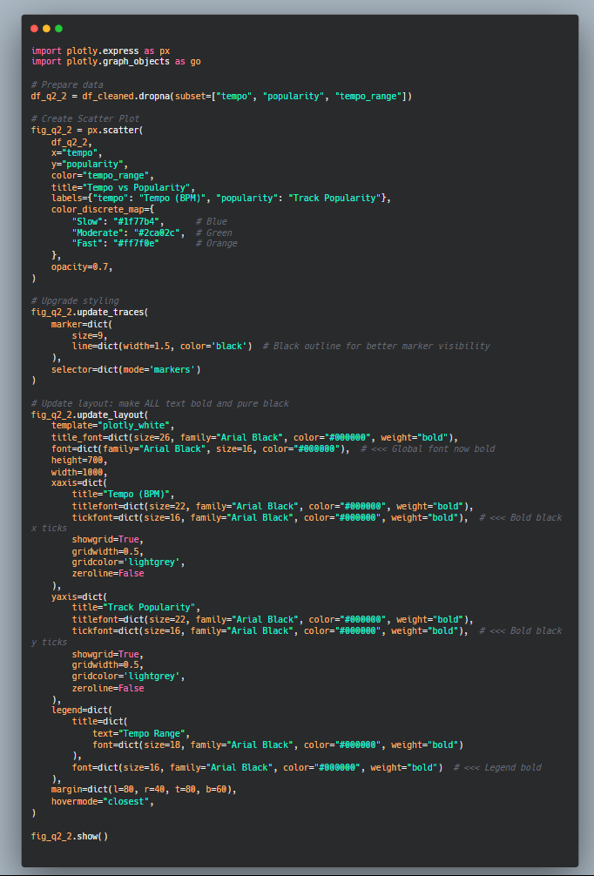

Code Snippet Tempo vs Popularity

### 

This scatter plot shows how tempo (BPM) relates to track popularity on Spotify. Moderate-tempo songs are more common among higher popularity scores, while fast and slow tempos vary widely, suggesting tempo influences popularity contextually rather than directly.

## **Question 3.3: Are Popular Tracks More Energetic?**

### **Introduction: Purpose and Context**

This visualisation explores the relationship between track popularity and energy level, using Spotify’s audio feature dataset. In Spotify’s framework, “energy” measures the perceptual intensity and activity of a track, incorporating elements like loudness, tempo, dynamic range, and instrumentation. This question asks:

Do popular tracks tend to be more energetic, or does energy not significantly influence popularity?

The inquiry is grounded in music psychology and audience behaviour research. High-energy music is often linked to heightened stimulation, emotional arousal, and memorability (Ilie & Thompson, 2006). In fast-paced digital environments—where user attention spans are short and rapid content consumption is the norm—it is reasonable to hypothesise that high-energy tracks might enjoy a popularity advantage. However, this assumption warrants empirical scrutiny.

### **Visual Interpretation and Analytical Insights**

The visualisation uses a lollipop chart to compare the average energy levels of tracks classified into three popularity tiers: low, medium, and high. Each category is represented by a vertical line with a circular marker at the top, highlighting the mean energy value for that group. This chart style provides a clean and immediate visual comparison between groups while maintaining simplicity.

The results present an intriguing counterintuitive pattern. Tracks in the low popularity class register the highest mean energy level at 0.67, followed by the medium popularity group at 0.66. Tracks in the high popularity class have the lowest mean energy, averaging 0.63. Although these numerical differences are modest, the directional trend is noteworthy—it runs contrary to the assumption that high-energy music is inherently more successful.

This inversion could be explained in part by genre effects. Music with extreme energy—such as fast-paced EDM, metal, or hardcore rap—may resonate with niche audiences but lack broader mainstream appeal. Such songs may dominate specific listening contexts like gyms or clubs but struggle to achieve universal reach. Meanwhile, highly popular songs often embody moderate energy profiles that allow for cross-genre flexibility and inclusion in a wide range of curated playlists.

These findings align with Berlyne’s (1971) theory of arousal potential, which suggests that moderate levels of emotional and sensory stimulation tend to be the most widely preferred. Excessively intense stimuli may be overwhelming for the general listener, while lower-intensity tracks may be perceived as less engaging unless paired with other affective elements such as nostalgia or lyrical depth.

Additionally, Spotify’s algorithmic ecosystem may favour tracks that balance energy with other factors such as danceability, mood, and acousticness. As Celma (2010) highlights, recommender systems are calibrated not solely on song features but on user retention and behavioural patterns, which makes it unlikely that energy alone drives popularity.

### **Conclusion and Implications**

This analysis indicates that popular tracks are not necessarily more energetic. In fact, slightly lower energy levels are associated with higher popularity on average. This challenges simplistic narratives about energy driving attention and suggests that broad appeal may be linked more to balance and accessibility than sheer intensity.

For music producers and content strategists, the implication is clear: while energy contributes to engagement, overemphasising it may alienate wider audiences. Tracks that maintain a measured level of intensity without overwhelming the listener may have better prospects for long-term popularity and playlist inclusion. For data scientists and recommender system developers, this reinforces the need for multidimensional modelling when predicting music success.

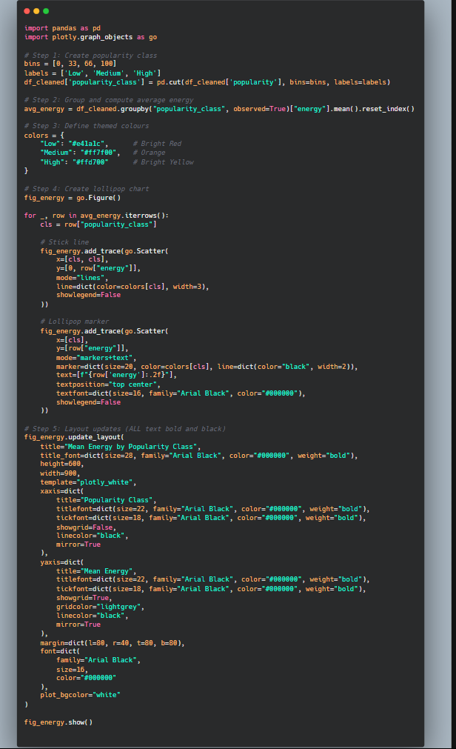

Code Snippet of Mean Energy by Popularity Class

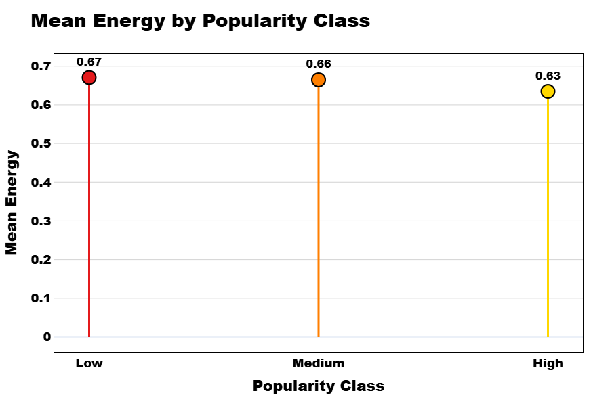

This lollipop chart displays the mean energy levels of Spotify tracks across low, medium, and high popularity classes. Contrary to expectation, low popularity tracks show the highest average energy, while high popularity songs have the lowest. This suggests that extreme energy may reduce mainstream appeal.

## **Question 4: Most Common and Popular Genres Insight**

### **Introduction: Purpose and Context**

This visualisation investigates the most **common primary genres** within the dataset by examining their distribution as a proportion of total entries. The guiding research question is:

Which genres appear most frequently in the top Spotify tracks, and what might this indicate about the dominant musical preferences among listeners?

Understanding genre prevalence allows us to identify patterns in musical production, promotion, and cultural consumption. Genres function as social categories as well as commercial tools—defining not only sound but also expectations, target audiences, and marketing strategies. In the age of algorithmic music delivery, frequency of genre appearance can also reveal how streaming platforms like Spotify amplify certain musical identities over others (Eriksson et al., 2019).

### **Visual Interpretation and Analytical Insights**

The chart is rendered as a **donut chart**, a variation of the pie chart that uses a central blank space to improve readability while maintaining proportional clarity. Each segment represents a primary genre, with its corresponding percentage indicating how frequently it appears in the dataset. The chart displays the **top 10 primary genres**, clearly annotated with labels and separated slightly for emphasis.

From the visualisation, **‘album rock’** emerges as the most dominant genre, representing **21.9%** of the top tracks. This genre’s prevalence reflects its historical and commercial significance. Album rock typically features guitar-driven, radio-friendly music from bands whose legacy spans decades. Its ongoing representation in the digital era may be partly explained by intergenerational streaming, continued playlist inclusion, and strong cultural capital (Bourdieu, 1984). Such tracks are often curated into “classic rock” collections that benefit from algorithmic reinforcement.

Following closely are **‘australian rock’ (17%)**, **‘adult standards’ (16.1%)**, and **‘dance pop’ (13.5%)**. These genres blend regional identity, timeless vocal performance, and danceability—attributes that perform well across diverse listening contexts, including passive environments like driving or working. Their presence underlines the enduring value of **musical familiarity and emotional accessibility**—traits that align with theories of musical preference driven by memory, cultural familiarity, and rhythmic engagement (Margulis, 2013; North & Hargreaves, 1997).

Less frequent genres in this chart include **‘bubblegum pop’, ‘europop’, ‘disco’, ‘alternative metal’, and ‘australian alternative rock’**, each accounting for 4–6% of the dataset. These genres, while not as dominant, still contribute to the sonic diversity of popular music. Their inclusion hints at **subcultural niches** and **temporal resurgences** (e.g. the revival of disco elements in modern pop), and suggests that while frequency is one dimension of popularity, cultural moment and aesthetic trends also shape genre relevance.

Notably, the chart reflects a strong Western-centric dataset, with genres rooted in Anglophone traditions dominating the top ten. This highlights how **global streaming visibility is unevenly distributed**, reinforcing critiques that algorithmic recommendation engines often replicate existing biases in cultural capital and exposure (Celma, 2010; Werner, 2021).

### **Conclusion and Implications**

The visualisation reveals that a small cluster of genres—particularly album rock, adult standards, and dance pop—account for a substantial proportion of top tracks. These genres are notable for their cross-generational appeal, rhythmic familiarity, and market-tested structures, which contribute to their algorithmic promotion and user retention.

This has several implications. For music producers and marketers, aligning with dominant genres may enhance discoverability and playlist placement, particularly if tracks are designed to fit within popular mood- or activity-based categories. For platform designers and researchers, the concentration of a few genres raises questions about genre diversity and recommendation fairness. Expanding algorithmic exposure to underrepresented genres could help decentralise cultural influence and broaden user engagement.

Ultimately, genre frequency does not equate to creative dominance but reveals how industrial systems—platforms, metadata, and curated playlists—shape what becomes familiar, frequent, and heard.

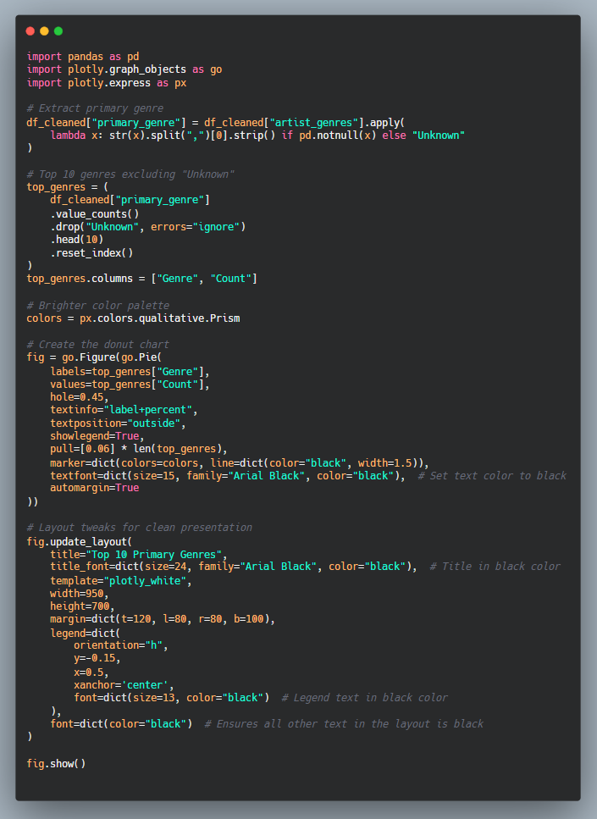

Code Snippet of Top 10 Primary Genres

### 

This interactive donut chart displays the top 10 most common primary genres in the Spotify dataset. ‘Album rock’, ‘australian rock’, and ‘adult standards’ are the most frequently occurring genres, highlighting the strong influence of rock, vocal standards, and familiar rhythmic structures in popular music.

## **Question 5: How Prevalent Are Explicit Tracks in the Dataset?**

### **Introduction: Purpose and Context**

This visualisation investigates the distribution of clean versus explicit tracks in the dataset to understand how frequently tracks labelled with explicit content appear in popular music collections. The driving question for this analysis is:

What proportion of top tracks contain explicit content, and what does this reveal about mainstream music consumption and platform policies?

The explicit content label typically refers to tracks containing strong language, sexual references, or themes deemed inappropriate for general audiences. On streaming platforms like Spotify, this designation impacts parental controls, playlist inclusion, and audience reach. From a sociocultural perspective, the rise of explicit content in music has been linked to artistic freedom, genre identity (particularly in hip hop and trap), and shifting norms around censorship and self-expression (Herzog, 2019).

### **Visual Interpretation and Analytical Insights**

The chart presented is a **donut chart**, which visually separates two classes of tracks: **clean** and **explicit**. The circular shape and empty centre enhance legibility, making the categorical proportions immediately obvious. In this case, the division is stark: **98.5% of the tracks are clean**, while **only 1.52% are explicitly labelled**.

This overwhelming dominance of clean tracks suggests that explicit content is highly underrepresented in this dataset of popular music. The low percentage may be due to a variety of factors. First, it may reflect dataset bias—if the dataset was compiled from curated, general-audience playlists or commercial hits, it may naturally skew toward radio-friendly content. Second, platform policies and listener preferences likely play a role; clean versions of popular songs are more likely to be included in editorial playlists, promoted in advertisements, or shared across social media.

Moreover, music with explicit labels often belongs to specific genres such as hip hop, trap, or explicit pop, which, although culturally influential, may still face **structural gatekeeping** when it comes to mass distribution or algorithmic exposure. Research by Werner (2021) on algorithmic inequality highlights how platform design may amplify or suppress certain types of content, depending on metadata filtering, user settings, and monetisation constraints.

It is also worth considering the **commercial implications** of the explicit label. Clean tracks have broader market access, particularly in school, family, or retail environments. As such, record labels may prioritise clean edits or avoid explicit content in songs intended for mass consumption. This dynamic may create a feedback loop: clean tracks get more exposure, leading to higher stream counts and visibility, which in turn justifies further editorial emphasis on clean content.

### **Conclusion and Implications**

The visualisation reveals that **explicit tracks make up only 1.52%** of the dataset, suggesting a strong dominance of clean content in the most streamed or surfaced tracks. This indicates that **mainstream popularity continues to favour clean, broadly accessible music**, likely due to commercial, cultural, and platform-based filtering factors.

For artists and producers, this insight may inform content decisions depending on their target audience and marketing goals. For platform designers, the result raises important questions about inclusivity, genre representation, and the potential marginalisation of music that includes raw or socially challenging language. For researchers, this points to the need for deeper analysis across genre and platform layers to understand how content labelling intersects with musical success.

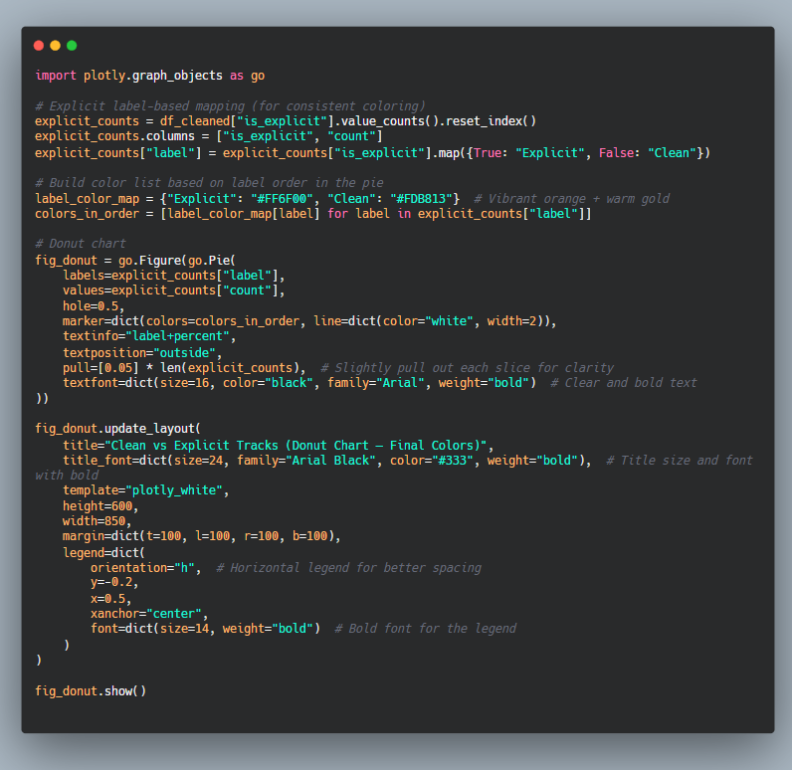

Code Snippet of Clean vs Explicit Tracks

### 

This interactive donut chart shows the proportion of clean versus explicit tracks in the dataset. Clean tracks dominate overwhelmingly at 98.5%, while explicit tracks make up just 1.52%, suggesting that mainstream music heavily favours non-explicit content.

## **Question 6.1: How Are Energy Levels Distributed Across Tracks?**

### **Introduction: Purpose and Context**

This visualisation examines how energy levels are distributed across all tracks in the dataset. Spotify defines energy as a numerical value between 0 and 1, where 0 indicates calm and mellow music, and 1 represents high-intensity, energetic tracks. The question posed is:

What is the overall distribution of energy across tracks, and what does this tell us about common patterns in music production and listener preference?

Energy is a core dimension in the psychology of music perception, shaping how listeners experience excitement, emotion, and engagement (Ilie & Thompson, 2006). It also plays a vital role in mood-based recommendation systems and curated playlists, making its distribution an important feature for understanding broader trends in music consumption.

### **Visual Interpretation and Analytical Insights**

The visualisation is a **histogram with a smoothed density curve**, displaying the number of tracks (y-axis) across the full range of energy levels (x-axis, from 0 to 1). Each vertical bar represents a bin of energy scores, while the smooth orange line provides a kernel density estimation of the distribution.

From the chart, it is clear that the distribution of energy levels is **skewed toward the higher end** of the spectrum. The majority of tracks cluster between **0.6 and 0.9**, with the most frequent range being around **0.7 to 0.8**. This suggests that most tracks in the dataset exhibit **moderate to high energy**, aligning with listener preferences for music that feels lively, emotionally stimulating, or danceable.

The left side of the histogram, representing low-energy tracks (0.0 to 0.3), shows very low counts. This indicates that **calm or subdued tracks are rare** in the dataset, potentially due to their limited inclusion in mainstream playlists or commercial releases. These types of songs—such as acoustic ballads, minimalist instrumentals, or ambient genres—are more likely to be favoured in niche listening contexts and are less often associated with high streaming volumes.

The density curve mirrors the bar chart’s general trend but also highlights subtle shifts in slope, suggesting a slight flattening at the very peak. This may indicate that while high-energy music is dominant, there is no singular “sweet spot”—rather, popular music tends to span a range within the energetic upper-mid zone.

This pattern aligns with research suggesting that **music perceived as moderately arousing is more likely to be preferred and remembered**, as it balances excitement without overstimulation (Berlyne, 1971). Furthermore, in the context of platform algorithms, high-energy tracks are more likely to be promoted in activity-based playlists (e.g., workout, focus, party), increasing their exposure and stream count over time.

### **Conclusion and Implications**

This analysis reveals that the majority of tracks in the dataset fall within the **moderate to high energy range**, with a strong bias toward energetic music. Calm tracks, while artistically significant, are comparatively underrepresented.

These findings have practical implications for music producers, playlist curators, and digital marketers. Creating tracks with medium-to-high energy levels may increase their likelihood of being picked up by algorithms or included in mainstream playlists. For researchers and developers of music recommendation systems, the skew in energy distribution calls for **greater awareness of potential biases**, ensuring that calmer, more reflective tracks are not marginalised by energy-based ranking models.

Finally, for audiences and cultural analysts, the results reflect modern music's lean toward engagement, movement, and stimulation—a sonic landscape shaped as much by emotional design as by platform logic.

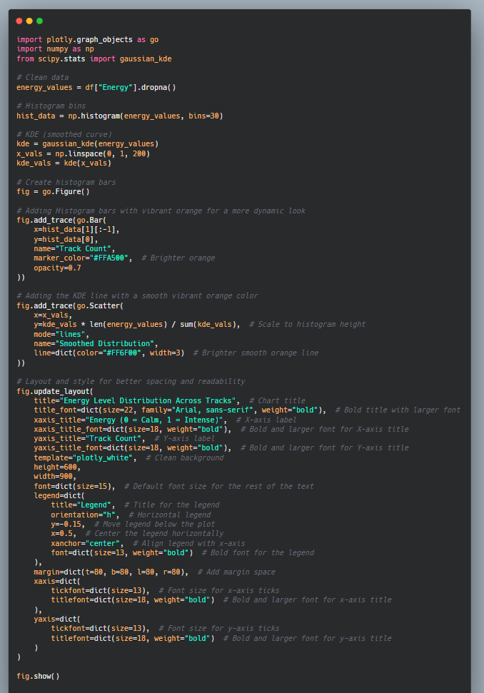

Code Snippet of Energy Level Distribution Across Tracks

### 

This interactive histogram with a smoothed density line shows how energy is distributed across tracks. Most tracks cluster between 0.6 and 0.9, indicating a strong preference for energetic music, while calm tracks are relatively rare in the dataset.

## **Question 6.2: How Danceable Are Most Tracks in the Dataset?**

### **Introduction: Purpose and Context**

This visualisation aims to explore the distribution of **danceability scores** across all tracks in the dataset. Danceability, as defined by Spotify’s audio features, quantifies how suitable a track is for dancing based on tempo, rhythm stability, beat strength, and overall musical regularity. It is measured on a scale from **0 (least danceable) to 1 (most danceable)**. The research question is:

What is the general distribution of danceability among tracks, and what insights can be drawn about music design and listener engagement?

Danceability is a significant factor in music perception and listener behaviour, particularly in contexts such as social events, workouts, and algorithmic playlists. It is also tightly linked to **embodied cognition** in music, where rhythmic features elicit motor responses and physical movement (Janata, Tomic & Haberman, 2012). Therefore, analysing its distribution helps to uncover how music is shaped for both physical engagement and commercial viability.

### **Visual Interpretation and Analytical Insights**

The visualisation is a **histogram with a smoothed red density curve**, showing the number of tracks (y-axis) distributed across varying danceability values (x-axis). The bars represent track counts for each range of danceability, while the curve outlines the general distribution trend.

The chart reveals that **most tracks fall between 0.4 and 0.75** on the danceability scale, with a **peak concentration around 0.6 to 0.7**. This suggests that a significant portion of tracks are **moderately to highly danceable**, reflecting a strong emphasis on rhythmic structure and listener engagement in track design.

The distribution forms a moderately skewed bell shape, with a clear tail toward the high-danceability end, tapering off after 0.85. On the low end, there are relatively few tracks with danceability below 0.3, indicating that music considered "less danceable" is a minority within the dataset. Such tracks may include ballads, classical instrumentals, ambient works, or experimental music, which generally lack strong rhythmic cues.

This clustering around the middle-high range implies that producers and artists consistently craft music that aligns with **movement-inducing characteristics**, possibly to increase playlist inclusion and appeal across a wider array of listening contexts. As studies in digital music marketing indicate, tracks that balance rhythm and regularity tend to perform better in streaming environments, especially when incorporated into playlists curated for energy, mood, or activity (Eriksson et al., 2019).

The smoother density curve further confirms this trend, gently rising and peaking before tapering off beyond 0.75. This reflects not only musical design choices but also **algorithmic influence**—Spotify’s recommendation systems are optimised for listener retention, and danceable music is more likely to sustain attention across diverse audiences (Celma, 2010).

### **Conclusion and Implications**

This analysis shows that the **majority of tracks in the dataset are moderately to highly danceable**, with a pronounced peak around 0.6 to 0.7 on the scale. Tracks with very low or very high danceability are less common, indicating a general trend toward musical moderation—tracks that are rhythmic and engaging, yet not overly specialised in one direction.

For artists, this insight suggests that targeting a mid-to-high danceability range may improve a track’s compatibility with playlists and algorithmic discovery. For developers of recommender systems, it highlights the importance of preserving diversity, ensuring that highly artistic but less danceable music is not systematically excluded. Finally, for researchers, the chart reinforces the role of danceability as a key aesthetic and functional dimension of contemporary popular music.

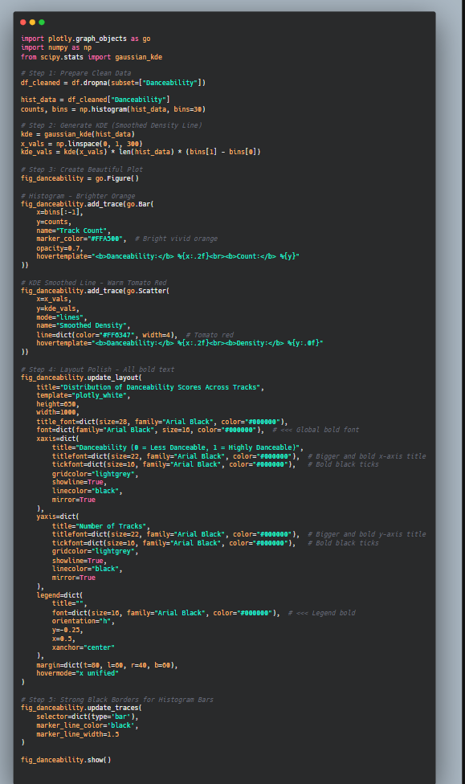

Code Snippet of Distribution of Danceability Scores Across Tracks

### 

This interactive histogram shows the distribution of danceability scores for tracks in the dataset. Most tracks fall between 0.4 and 0.75, with a peak around 0.65, suggesting that popular music often targets a balance between rhythm and accessibility for movement-based listening.

## **Question 6.3: How Are Tracks Distributed by Emotional Valence?**

### **Introduction: Purpose and Context**

This visualisation investigates the emotional valence distribution of tracks within the dataset. Valence is a key musical feature used by Spotify to measure the emotional positivity of a track, ranging from **0 (very sad or tense)** to **1 (very happy or euphoric)**. To aid interpretability, valence has been categorised here into five mood-based bins: Very Sad, Sad, Neutral, Happy, and Very Happy. The guiding research question is:

What emotional valence is most common among tracks, and what does this suggest about the emotional tone of popular music?

Emotional valence plays a crucial role in listener engagement, playlist curation, and mood-based recommendation algorithms. It also reflects broader cultural trends in how music expresses and mediates emotional experience (Juslin & Sloboda, 2010). Understanding its distribution provides insights into both audience demand and artistic production.

### **Visual Interpretation and Analytical Insights**

The chart is a **horizontal bar plot**, which effectively displays the count of tracks in each valence category. This format is well-suited for comparing discrete categories, especially when category labels are textual and differ in length.

The analysis reveals that the **'Happy'** category contains the largest number of tracks (**2,688**), followed closely by **'Neutral'** (**2,502**) and **'Very Happy'** (**2,288**). These three categories represent the **majority of the dataset**, indicating that popular music tends to exhibit **moderate to high emotional positivity**. In contrast, **'Sad'** and **'Very Sad'** tracks are less common, with **1,867** and **650** tracks respectively.

This skew toward higher valence reflects a strong preference for emotionally uplifting or stable music in popular contexts. Such music is more likely to be used in social settings, featured in general-purpose playlists, and promoted by streaming algorithms that favour feel-good or energising content. It aligns with research that shows **positive emotion in music enhances listener satisfaction, memorability, and replay likelihood** (North & Hargreaves, 1997).

Interestingly, the large presence of Neutral tracks suggests a tendency toward emotional ambiguity or balance—music that does not strongly lean toward happiness or sadness. This may indicate a preference for versatility in listening contexts, or it may reflect the structural design of many modern tracks that combine upbeat instrumentation with introspective or complex lyrical themes.

The relatively lower presence of Sad and Very Sad tracks highlights a potential **bias in commercial music production** and algorithmic promotion, where darker emotional tones may be seen as less universally appealing. However, this does not mean such tracks lack cultural significance. Sad music often enjoys strong fan loyalty, especially in genres like R&B, alternative rock, and indie folk, where emotional depth is valued over mass appeal (Taruffi & Koelsch, 2014).

### **Conclusion and Implications**

This analysis shows that **popular music is predominantly skewed toward positive or neutral emotional valence**, with happy and very happy tracks making up a substantial portion of the dataset. While sadder tracks are present, they are less frequent, suggesting that emotional uplift is a dominant aesthetic and commercial priority in contemporary streaming environments.

For producers and songwriters, this insight underscores the commercial viability of positive emotional expression. For streaming platforms, it raises questions about emotional diversity in algorithmic recommendations and whether listeners are given access to a broad emotional range. Finally, for cultural analysts, the findings reflect an underlying societal narrative: the modern music landscape promotes positivity, even when reality may be more complex.

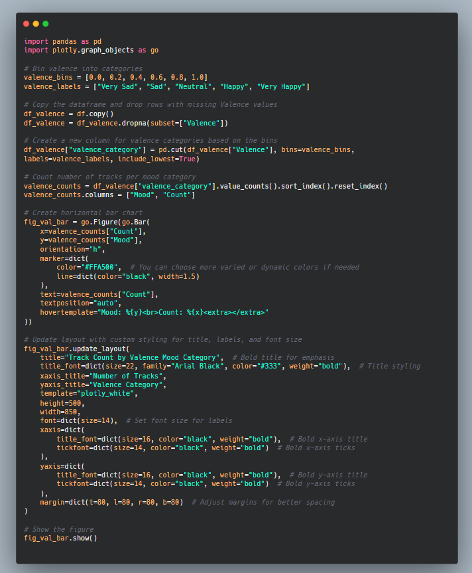

Code Snippet of Track Count by Valence Mood Category

### 

This interactive bar chart shows the number of tracks in each valence mood category. Most tracks are categorised as Happy, Neutral, or Very Happy, suggesting that positive or emotionally stable music dominates the dataset, while sadder emotional tones are less frequent.

## **Question 8: Relationship Between Loudness and Speechiness**

### **Introduction: Purpose and Context**

This visualisation explores the relationship between two audio characteristics—**loudness** and **speechiness**—to identify whether speech-like qualities in tracks correlate with their dynamic intensity. In Spotify’s audio analysis framework, **loudness** is measured in decibels (dB) and reflects the overall perceived volume of a track, while **speechiness** scores between 0 and 1, estimating how much a track resembles spoken word. The guiding research question is:

Is there a discernible relationship between a track’s loudness and its speechiness, and what might this imply about genre patterns or production styles?

Speechiness is commonly associated with rap, podcasts, and spoken word performances, while loudness is shaped by production choices and genre conventions. Understanding their interplay may provide insights into how music producers balance lyrical clarity with sonic intensity, especially in genres where speech-like delivery is central.

### **Visual Interpretation and Analytical Insights**

The chart is a **smoothed density contour plot**, which displays the density of data points using heatmap-style colour gradients layered with contour lines. The x-axis represents loudness (with values in negative dB, where 0 is the maximum possible volume), while the y-axis shows speechiness values. The colour scale on the right indicates point density, from low (light yellow) to high (dark brown).

The densest concentration of tracks is found around a **loudness level of -27 dB** and a **speechiness range of 0.4 to 0.55**. This indicates that the majority of tracks with moderate speech-like qualities cluster at **lower loudness levels**, suggesting a possible trade-off between speech clarity and volume. Tracks with **higher speechiness** may rely on quieter, less compressed mixes to preserve the intelligibility of the vocal delivery.

Importantly, the plot reveals that **high loudness and high speechiness rarely co-occur** in the dataset. This makes sense from an acoustic and perceptual standpoint. As discussed in auditory processing literature, louder tracks often involve compression and mixing techniques that can reduce the clarity of enunciated words, making high speechiness difficult to maintain at extreme loudness levels (Zwislocki, 2002).

This pattern may also be genre-related. For instance, hip hop tracks with high speechiness may feature minimalist instrumentation and moderate loudness to foreground lyrics, while heavily produced pop or EDM tracks may prioritise instrumental volume over vocal articulation. This finding aligns with scholarly work on genre-specific production aesthetics and listener decoding strategies (Moore, 2012).

Additionally, the overall narrow band of loudness observed in the plot—most tracks falling below -25 dB—suggests that the dataset favours moderately loud mixes, which offer dynamic range without distortion or listener fatigue. Such mixing standards are common in streaming platforms where normalisation protocols aim to level volume across content (Spotify, 2020).

### **Conclusion and Implications**

This analysis suggests a **moderate inverse relationship** between loudness and speechiness. Tracks with speech-like characteristics tend to be quieter, likely to preserve vocal clarity and enhance lyrical intelligibility. Meanwhile, louder tracks typically have lower speechiness, focusing more on musical than verbal elements.

For music producers, this insight supports careful attention to dynamic range when working with spoken vocals or rap elements. For curators and recommender system designers, recognising the interplay between loudness and speechiness can improve playlist diversity and contextual recommendations—for example, by separating “spoken performance” content from “high-energy” listening contexts.

Finally, this relationship underscores the subtle interaction between acoustic design and genre identity—where how loud a track is and how much it resembles speech are not just technical details but key ingredients of musical meaning and listener experience.

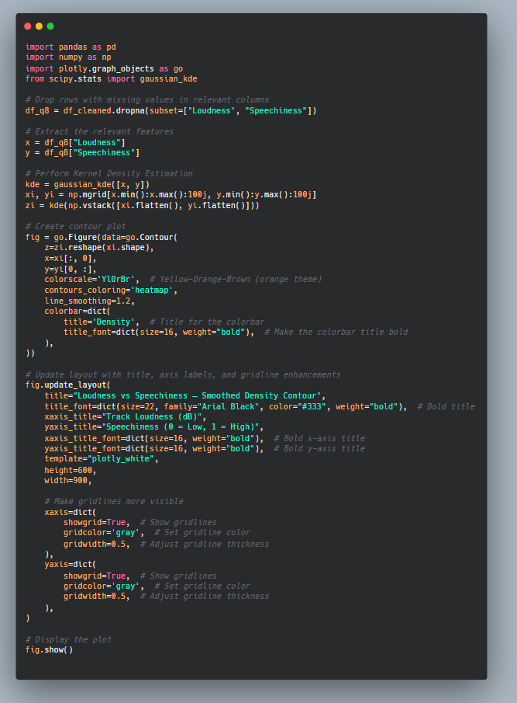

Code of Snippet of Loudness vs Speechiness

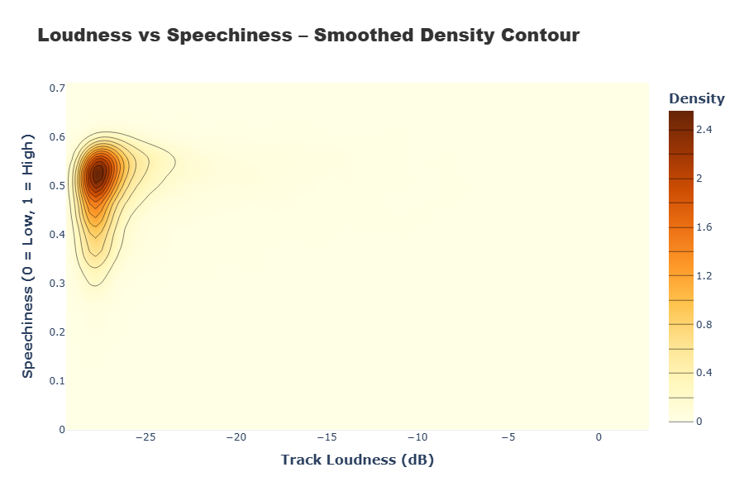

### 

This interactive smoothed density contour plot shows the relationship between loudness and speechiness in Spotify tracks. Most tracks with moderate speech-like qualities occur at lower loudness levels, while high loudness and high speechiness rarely overlap, suggesting a trade-off between volume and vocal clarity.

## **Question 9: Are Longer Tracks More Popular?**

### **Introduction: Purpose and Context**

This visualisation investigates the potential relationship between track duration and popularity, using Spotify data. The research question driving this analysis is:

Does a track’s length influence its popularity, or is popularity unaffected by duration?

Track duration is a fundamental structural feature of music that impacts listener engagement, streaming algorithms, and user retention. On streaming platforms, shorter tracks often benefit from **replay frequency and platform monetisation strategies**, while longer tracks may appeal to more immersive listening experiences. This analysis seeks to uncover whether track length has a measurable influence on popularity within contemporary digital consumption contexts.

### **Visual Interpretation and Analytical Insights**

The chart is a **scatter plot** plotting track duration (in minutes) on the x-axis and track popularity (on a 0–100 scale) on the y-axis. Each point represents a track, and an orange regression line overlays the data to suggest the general trend.

The majority of tracks fall between **2 and 5 minutes**, reflecting industry norms for single releases, radio play, and playlist compatibility. Within this common duration range, popularity varies widely. Many tracks near the 3–4 minute mark achieve high popularity scores (above 70), but so too do shorter and slightly longer tracks, indicating that **duration alone does not determine popularity**.

Interestingly, a very slight **positive trend** can be observed in the regression line—suggesting that, on average, longer tracks may be marginally more popular. However, this trend is weak and should be interpreted cautiously, as the spread of data points shows high variance. A number of **longer tracks (10+ minutes)** appear to achieve moderate popularity, but these are outliers and may reflect unique cases (e.g., concept tracks, live recordings, or legacy songs with niche audiences).

The spread of short-duration tracks with both low and high popularity also reflects the rise of **micro-content consumption**, driven by platforms like TikTok and Instagram Reels. These platforms have contributed to a shift in listener attention spans and production norms, where shorter tracks are designed for viral loops, repeat listening, and rapid sharing (Morris & Powers, 2015).

Furthermore, industry monetisation incentives may influence song length. Spotify, for example, counts a stream after 30 seconds of listening, potentially encouraging artists to create shorter songs that maximise plays per minute (Spotify for Artists, 2023). As a result, **shorter tracks may be disproportionately designed for commercial efficiency**, rather than creative expression.

This insight ties into **uses and gratifications theory**, where users seek content that aligns with their time, mood, and goals (Katz, Blumler & Gurevitch, 1974). Shorter tracks offer quick gratification, while longer tracks may be reserved for immersive or reflective listening contexts—often outside of algorithm-driven discovery paths.

### **Conclusion and Implications**

The visualisation shows that **track duration is not a strong predictor of popularity**, although a slight positive correlation is observable. Most popular tracks fall within the 2–5 minute range, which appears to be the optimal window for balancing user attention, playlist compatibility, and streaming monetisation.

For artists and producers, this analysis suggests that **creative flexibility exists within standard duration formats**, but extremely long or extremely short tracks may face discoverability and engagement challenges. For platform designers and recommendation system developers, it highlights the importance of accounting for duration when evaluating performance metrics—particularly when longer tracks might receive fewer plays but offer deeper engagement.

Ultimately, the weak relationship between duration and popularity reflects a broader reality of streaming culture: **popularity is shaped less by structural length and more by content appeal, algorithmic promotion, and audience context**.

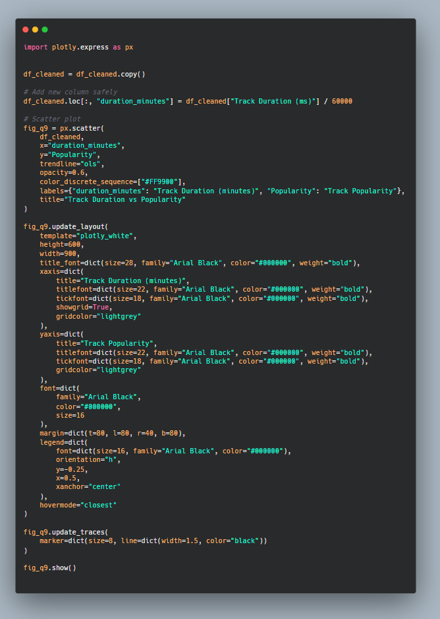

Code Snippet of Track Duration vs Popularity

### 

This interactive scatter plot shows track duration versus popularity. While most popular tracks fall between 2 and 5 minutes, a slight positive trend suggests that longer tracks may be slightly more popular, though the relationship is weak and varies significantly across durations.

## **Question 10: Analysis of Tempo & Danceability Combinations**

### **Introduction: Purpose and Context**

This visualisation explores the **interaction between tempo and danceability** in popular music, examining how combinations of these two core audio features appear across tracks. Tempo (measured in beats per minute, BPM) determines how fast or slow a track feels rhythmically, while danceability refers to how easily a track can be moved to, based on rhythm clarity, tempo stability, and beat strength. The question addressed is:

Which combinations of tempo and danceability are most common, and what does this reveal about production trends and listener preferences?

These two features are closely linked to **embodied listening**—how music affects bodily movement and emotional states. In streaming contexts, tracks that optimise for both danceability and tempo are often prioritised in **activity-based playlists** (e.g., workouts, parties, focus), increasing their visibility and replayability (Janata et al., 2012; Hagen & Lüders, 2017).

### **Visual Interpretation and Analytical Insights**

The visualisation is a **bubble plot**, where each circle represents a unique combination of tempo level (Slow, Moderate, Fast) and danceability level (Low, Medium, High). The **size** of each bubble reflects the **number of tracks** that fall into that combination, while the **colour intensity** (based on a sequential scale) also corresponds to frequency.

The most striking insight is the **dominance of moderate tempo with medium danceability**, represented by the **largest and brightest bubble**. This suggests that tracks optimised for **moderate rhythmic speed and moderate movement potential** are the most common in the dataset. These tracks likely balance energetic engagement and broad accessibility—making them ideal for general-purpose playlists and mainstream audiences.

The next most populated combinations include **fast tempo with medium danceability** and **moderate tempo with high danceability**. These combinations reflect the industry's preference for rhythmically engaging music that encourages movement but does not push into extremes. Such tracks are typical in commercial pop, upbeat indie, and dance music that appeals to a wide demographic.

At the opposite end, **slow tempo combined with either low or high danceability** is relatively rare, as indicated by the **small, dark bubbles**. Tracks with **low danceability and slow tempo** may lack strong rhythmic drive, making them less suitable for public-facing contexts. Meanwhile, **slow but highly danceable tracks**, although musically possible (e.g., R&B ballads or downtempo grooves), are comparatively uncommon—perhaps due to their niche appeal or algorithmic invisibility.

Interestingly, **fast tempo and high danceability** is also not the most common combination, despite being ideal for dancefloor settings. This suggests that **extreme rhythmic intensity** might have limited mainstream appeal, reinforcing the industry’s reliance on **moderation and versatility**.

This pattern supports the notion of **aesthetic optimisation** in popular music, where artists and producers intentionally craft tracks to fit into **algorithmic norms and behavioural playlists** (Eriksson et al., 2019). It also aligns with **uses and gratifications theory**, where listeners choose music that fits routine activities—thus favouring songs that are neither too intense nor too passive (Katz et al., 1974).

### **Conclusion and Implications**

This analysis shows that **tracks with moderate tempo and medium danceability dominate the dataset**, revealing a strong preference for balance in musical design. Extreme combinations—such as fast and low danceability or slow and high danceability—are rare, suggesting that producers aim for accessibility and general appeal over experimentation.

For artists and producers, this insight offers a practical benchmark for designing music that aligns with listener expectations and streaming algorithms. For platform designers, it suggests that **algorithmic feedback loops may be reinforcing specific aesthetic patterns**, potentially at the expense of sonic diversity.

Finally, for researchers and cultural analysts, the data reinforces the idea that modern popular music is **engineered for functional versatility**, reflecting the fusion of human preference, cultural habit, and technological mediation.

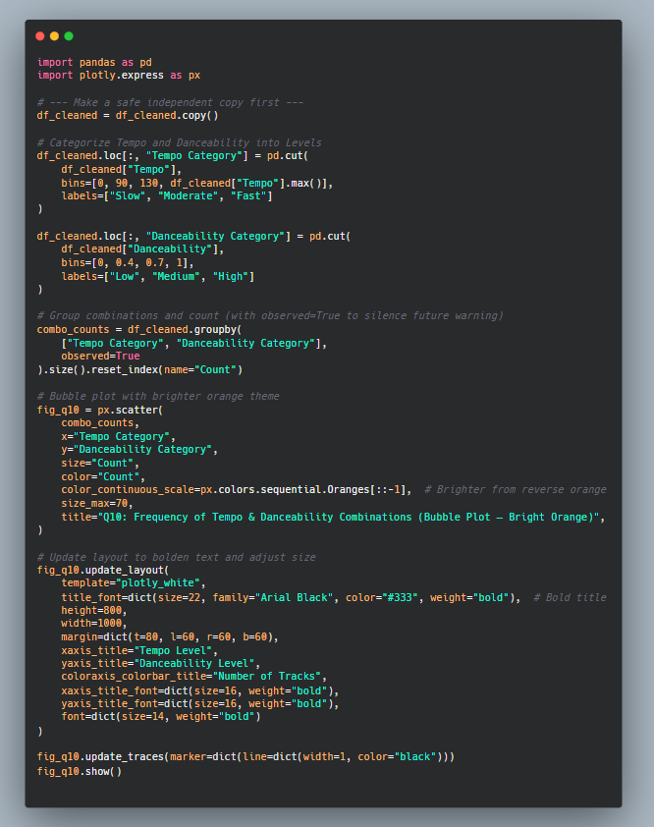

Code Snippet of Frequency of Tempo & Danceability Combinations

### 

This interactive bubble chart shows the frequency of tempo and danceability combinations. Tracks with moderate tempo and medium danceability are the most common, while extreme combinations like slow-high or fast-low are rare, suggesting a production bias toward rhythmic balance and broad listener appeal.

## **Question 11: What Are the Most Common Musical Keys Among Popular Tracks?**

### **Introduction: Purpose and Context**

This visualisation explores the **distribution of musical keys** across tracks in the dataset. In music theory, a key refers to the tonal centre of a piece and defines its harmonic structure. Spotify’s audio analysis identifies each track’s key based on pitch class notation, ranging from **C to B**, including sharps/flats (e.g., F♯/G♭). The primary question this visual answers is:

Which musical keys appear most frequently among popular tracks, and what patterns can be observed in their usage?

The selection of musical key can significantly affect a song’s **emotional tone, genre alignment**, and **vocal range suitability**. Furthermore, certain keys are often more common in digital music production due to instrument tuning conventions and genre-specific traditions (Temperley, 2007). By analysing key frequency, we gain insight into the tonal norms shaping popular music.

### **Visual Interpretation and Analytical Insights**

The chart is a **rose donut chart**, a variation of a pie chart that uses circular segments to compare categorical proportions. Each wedge represents a musical key, and the size of each segment corresponds to the percentage of tracks using that key. The chart uses an **orange-matched colour palette** for thematic consistency and highlights the top slices using slight separation.

The most frequently used key is **C major**, appearing in **13.3%** of the tracks. This is unsurprising given that C major contains no sharps or flats, making it **technically simple and harmonically neutral**. It is especially popular in beginner compositions, piano-centric songwriting, and genres that favour tonal clarity.

Following closely are **A major (10.5%)**, **G major (10.8%)**, and **D major (10.3%)**. These keys are common in guitar-based music due to their **natural compatibility with open string tuning**, making them popular in rock, folk, and country genres (Everett, 2004). Their tonal brightness also contributes to their use in upbeat or emotionally positive songs.

On the other end of the spectrum, keys such as **D♯/E♭ (2.98%)**, **G♯/A♭ (6.18%)**, and **A♯/B♭ (6.22%)** appear far less frequently. These keys, while musically valid, involve more complex notation and may be avoided in production due to **transpositional difficulty** or **incompatibility with certain instruments**. Additionally, some digital audio workstations (DAWs) and MIDI systems default to simpler keys, reinforcing this trend in electronic and sample-based production.

Notably, **minor keys are underrepresented** in this visualisation, though the dataset does not distinguish between major and minor modes explicitly. This points to a potential **bias toward major tonalities**, which are often associated with **positive emotional valence**, aligning with findings in Question 6.3 (Juslin & Sloboda, 2010).

The relatively even spread among the top keys also suggests **tonal diversity**, indicating that while some keys dominate, producers still draw from a broad tonal palette—likely influenced by genre conventions, vocal requirements, and stylistic experimentation.

### **Conclusion and Implications**

This analysis shows that **C, G, A, and D major** are the most frequently used keys in popular music, likely due to their **technical simplicity, instrumental compatibility, and tonal brightness**. Less common keys such as D♯/E♭ and G♯/A♭ appear less frequently, reflecting both **musical and production-based constraints**.

For music creators, understanding these trends can inform choices in composition and production to maximise accessibility or differentiate stylistically. For streaming platforms, recognising tonal trends can support better mood and genre-based playlist curation. From a theoretical perspective, the dominance of certain keys confirms that tonal convention, ease of play, and sonic clarity remain key drivers in the digital age of music creation.

## 

Code Snippet of Musical Keys Among Popular Tracks

### 

This interactive rose donut chart shows the distribution of musical keys across tracks. C major is the most common, followed by A, G, and D. These keys are favoured for their simplicity and compatibility with popular instruments, while less common keys appear in fewer tracks due to tonal or technical complexity.

## **Question 13: How Have Audio Features Evolved Across Decades?**

### **Introduction: Purpose and Context**

This visualisation provides a temporal analysis of key Spotify audio features—including acousticness, danceability, energy, instrumentalness, speechiness, valence, and tempo—across multiple decades, from the 1950s to the 2010s. The guiding research question is:

How have core musical attributes changed over time, and what do these shifts reveal about the evolution of popular music and listener preferences?

Musical features are shaped by both **technological advancements and cultural shifts**. From the introduction of multitrack recording to the rise of electronic instrumentation, digital streaming, and AI-curated playlists, each era has influenced how music is produced, consumed, and valued. This analysis interprets how such historical forces are reflected in the evolution of quantifiable audio characteristics (Théberge, 1997; Leyshon, 2001).

### **Visual Interpretation and Analytical Insights**

The chart presents a **multi-line plot** tracking the average values of seven audio features across decades. All features except **tempo** are scaled from 0 to 1 on the left y-axis. **Tempo** is displayed on a secondary y-axis (right), measured in beats per minute (BPM), to allow comparative reading without distorting scale.

#### **1. Acousticness**

Acousticness shows a **sharp decline** from 1950 (near 0.7) to 2010 (around 0.12), indicating a gradual move away from organic instrumentation (e.g., piano, strings, acoustic guitar) toward **digitally produced or electronically enhanced soundscapes**. This trend aligns with the rise of synthesizers, drum machines, and DAWs, especially post-1980s (Moore, 2012).

#### **2. Danceability and Energy**

Both **danceability** and **energy** rise steadily from the 1970s onward, peaking around the 2000s. Danceability increases from ~0.5 to ~0.62, and energy from ~0.52 to ~0.76. These patterns correspond with the commercial success of **dance-pop, EDM, and hip-hop**, where rhythmic clarity and energetic delivery dominate production values. This shift may also reflect platform-based reinforcement, as energetic tracks tend to drive **higher user engagement and playlist retention** (Eriksson et al., 2019).

#### **3. Speechiness**

Speechiness remains relatively flat, averaging around 0.55, but with a **notable decline in the 2000s and 2010s**. This suggests a possible **decline in spoken-word vocal style**, particularly in mainstream content. The earlier spike may reflect the rise of **hip-hop in the 1980s and 1990s**, where speech-style delivery is core. However, with the commercial fusion of melodic rap and pop-rap, speechiness may now be **modulated by melodic hooks and autotuned vocals** (Adams, 2009).

#### **4. Valence**

Valence—a measure of musical positivity—has remained relatively **stable** over time, with values fluctuating modestly around 0.6. This suggests that the **emotional tone of music has not drastically changed** over the decades, despite shifts in production and genre dominance. However, the slight decline since the 1990s may reflect **increased genre diversification**, including more introspective or melancholic tones within mainstream music.

#### **5. Instrumentalness**

Instrumentalness remains consistently low across all decades (under 0.05), with only minor fluctuations. This underscores the enduring dominance of **vocal-led tracks** in popular music. Instrumental works, while valued in niche genres (e.g., ambient, classical, lo-fi), have rarely dominated mainstream charts or streaming trends.

#### **6. Tempo**

Tempo remains relatively **stable**, hovering between 118–124 BPM, with only small fluctuations across decades. Contrary to common belief that music has become significantly faster or slower, this suggests a **consistency in rhythmic pacing** despite radical genre evolution. This is likely due to the **ideal tempo range for walking, dancing, and general attentional engagement**, which lies near 120 BPM (Levitin et al., 2018).

### **Conclusion and Implications**

The visualisation reveals **clear and coherent shifts in musical characteristics** over time. Notably, music has become:

* **Less acoustic** and more electronically produced,
* **More danceable and energetic**, aligning with rhythmic, body-oriented genres,
* **Consistently vocal-driven**, with low instrumental presence,
* **Relatively stable in emotional tone and tempo**, despite changing aesthetics.

These patterns reflect not just technological and artistic changes, but also **platform-driven behaviours**—as digital streaming promotes audio features that favour **user engagement, repetition, and commercial performance**. For producers, understanding these feature trajectories is vital for tailoring songs to modern audiences. For musicologists and platform designers, the results highlight the **algorithmic reinforcement of certain sonic profiles** over time.

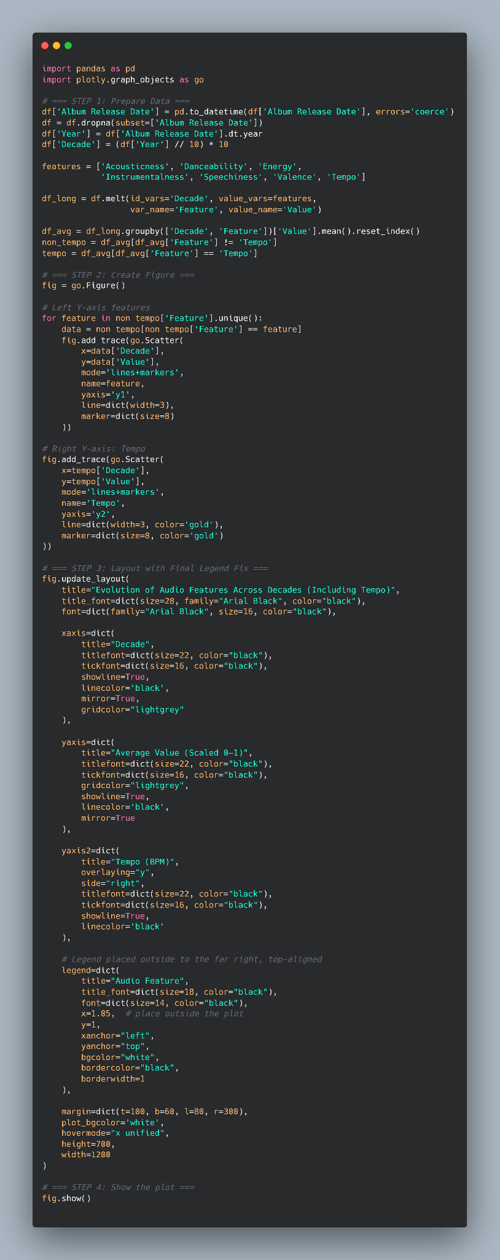

Code Snippet of Evolution of Audio Features Across Decades

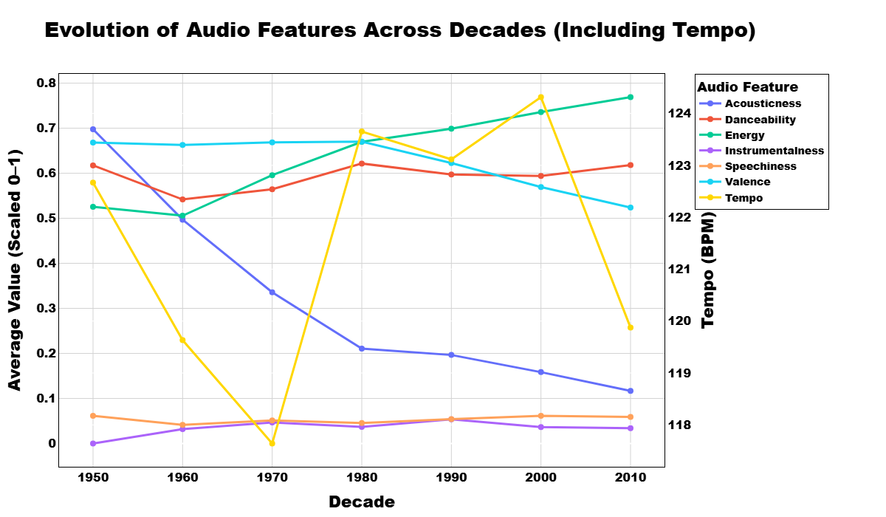

This multi-line chart tracks how audio features like acousticness, energy, danceability, and tempo have evolved by decade. Over time, popular music has become more energetic and danceable but less acoustic and speech-like, with tempo and valence remaining relatively stable.

## **Question 14: What Is the Overall Mood Distribution in the Dataset?**

### **Introduction: Purpose and Context**

This visualisation analyses the overall **mood distribution** of tracks based on Spotify’s valence metric, which measures the musical positivity of a track and is often used as a proxy for emotional mood. For this chart, valence scores have been **categorised into five emotional moods**: Very Sad, Sad, Neutral, Happy, and Very Happy. The key question addressed is:

How are different mood categories represented across popular tracks, and what does this suggest about emotional trends in music consumption and production?

The valence-emotion link reflects broader concepts in music psychology. Music often evokes affective states, and its emotional content strongly influences listener preference, memory, and behaviour (Juslin & Västfjäll, 2008). Understanding mood distributions can reveal what kinds of affective experiences dominate contemporary popular music.

### **Visual Interpretation and Analytical Insights**

The chart is an **exploded pie chart**, a stylistic variation where one segment (Very Sad 😭) is slightly pulled out to draw attention. Each wedge represents a mood category, and the percentage labels indicate the relative frequency of each mood class among tracks.

The data reveals a clear preference for **positive emotional tones**:

* **Happy**  tracks are the most frequent (26.9%)
* **Neutral**  tracks follow closely (25%)
* **Very Happy**  songs are also highly represented (22.9%)

Together, these three categories account for **almost 75%** of the dataset, reflecting a strong emphasis on **emotionally neutral to highly positive** musical content. This aligns with the platform-driven logic of streaming services, which favour emotionally uplifting or versatile tracks suitable for a wide range of social and situational playlists (Eriksson et al., 2019).

Meanwhile, **Sad**  tracks account for 18.7%, and **Very Sad**  songs are the least common at just **6.5%**. The exploded highlight of this smallest slice serves a dual purpose: visual emphasis and analytical commentary on its relative rarity.

This distribution suggests that while **sad music is still present**, it is underrepresented in comparison to its emotional and expressive importance in many listener contexts. This could be due to several reasons:

* Sad music may be more niche and preferred during solitary listening, thus underrepresented in playlist-focused, general-audience datasets.
* Platform curation and algorithmic recommendation systems may deprioritise emotionally intense or melancholic tracks in favour of mood-stabilising content (Serrà et al., 2012).

From a psychological perspective, this is noteworthy because **sad music has well-documented therapeutic and aesthetic benefits**, including emotional catharsis, empathy, and mood regulation (Taruffi & Koelsch, 2014). Its lower representation in streaming datasets may not reflect its true consumption in private settings.

### **Conclusion and Implications**

This mood-based analysis reveals that **positive and neutral emotions dominate popular music**, while **very sad moods are rare**. The prevalence of Happy and Neutral music suggests a preference for tracks that are **broadly accessible, emotionally manageable, and playlist-friendly**. While sad music remains culturally significant, its presence in popular datasets is marginal, possibly due to commercial and algorithmic biases.

For music creators, this points to the commercial viability of emotionally uplifting music. For platform designers, it raises important considerations about **emotional diversity and representational fairness** in recommender systems. For researchers, it suggests that **the emotional landscape of popular music may be skewed**, reflecting production logic rather than pure audience demand.

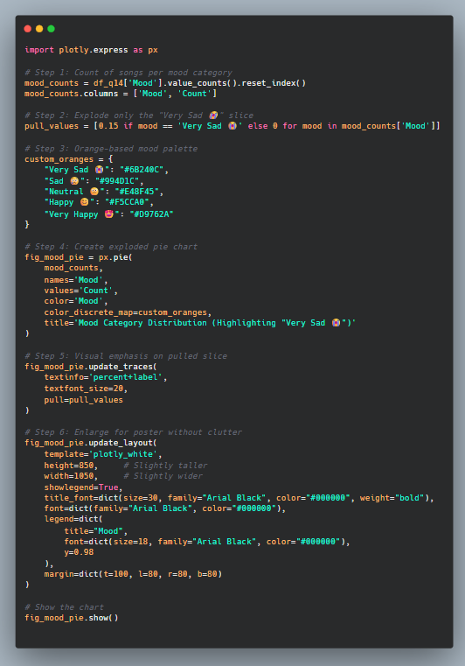

Code Snippet of Mood Category Distribution

### 

This exploded pie chart shows the distribution of mood categories derived from valence scores. Happy, Neutral, and Very Happy moods dominate the dataset, while Very Sad tracks are rare, accounting for just 6.5% of entries.

## **Question 15: How Do Genre, Popularity, and Explicitness Interact in Popular Tracks?**

### **Introduction: Purpose and Context**

This visualisation uses a **sunburst chart** to explore the hierarchical relationships between **primary genre**, **popularity class** (low, medium, high), and **explicitness** across tracks in the dataset. The guiding research question is:

How are popularity and explicit content distributed across different musical genres, and what trends can be observed from this interaction?

Explicitness in music reflects lyrical content that includes strong language or adult themes. It has cultural, commercial, and algorithmic implications—affecting playlist inclusion, parental control settings, and platform visibility (Werner, 2021). By combining this with genre and popularity dimensions, this sunburst chart offers a multifaceted look at how stylistic identity intersects with audience reception and lyrical choices.

### **Visual Interpretation and Analytical Insights**

The **sunburst chart** is a radial hierarchical plot that segments data in three concentric layers:

* The **innermost ring** represents the primary **genre** (e.g., dance pop, album rock, pop).
* The **middle ring** shows **popularity class** within each genre (low, medium, high).
* The **outermost ring** reflects **explicitness frequency** associated with each genre-popularity pair (simplified in this version into shaded bands of presence/absence rather than raw counts).

#### **Key Patterns Identified:**

1. **Dance Pop** Dance pop dominates the chart in breadth and depth, occupying a **significant portion across all popularity classes** (low, medium, high). This genre is known for its **mainstream appeal and rhythmic accessibility**, making it widely playlisted and commercially viable. Explicit content in dance pop appears across all popularity tiers, suggesting that **explicitness is tolerated when embedded within rhythmically engaging, upbeat formats**—a trend aligned with pop-rap and EDM collaborations (Marshall, 2015).
2. **Pop and Album Rock** Both genres show **diversity across popularity classes**, but pop exhibits a stronger tendency toward **explicit content at both high and low popularity levels**. This may reflect the influence of **youth-oriented themes** and identity-driven lyricism often found in emerging or indie pop subgenres, where self-expression trumps mass appeal.

Album rock, by contrast, shows **more balanced distributions**, with lower explicitness frequency. This aligns with the genre's tradition of **narrative and instrumentally rich structures**, which may prioritise lyrical storytelling over shock value or raw language.

1. **Adult Standards and Unknown Genres** These categories have minimal presence in the explicit layer and are skewed toward **low and medium popularity classes**. This is likely due to their stylistic alignment with **older audiences, classical arrangements, or vocal jazz traditions**, where lyrical content tends to be **cleaner, nostalgic, or thematically conservative** (Hamm, 1995).
2. **Explicitness Trends** Overall, **explicit content is more prevalent in mainstream genres like dance pop and pop**, especially at **both low and high popularity ends**. This reflects a **dual dynamic**: explicit content may help niche artists stand out in saturated markets, while also being tolerated or even marketed in high-performing tracks if embedded within accessible musical forms.

This phenomenon reflects **algorithmic tolerance** for explicit content within commercially proven formats, highlighting the tension between artistic freedom and platform constraints (Prey, 2020). The absence or marginalisation of explicit content in certain genres suggests **systematic gatekeeping** influenced by genre expectations, target demographics, and curation standards.

### **Conclusion and Implications**

This sunburst chart illustrates how **genre, popularity, and explicitness** intersect in contemporary music. **Dance pop and pop dominate both in reach and explicit content presence**, while genres like adult standards and album rock exhibit **more conservative lyrical trends**. Explicitness, once a marker of countercultural identity, now coexists with mainstream visibility—especially when packaged in sonically familiar or rhythmically engaging forms.

For artists, this insight suggests that the **acceptability of explicit content is genre- and context-dependent**. For curators and platform engineers, it reinforces the need to consider not just content flagging but **genre-informed thresholds** when designing content moderation and recommendation systems. Finally, for cultural researchers, this chart offers a visual snapshot of how **music reflects and negotiates boundaries between commerce, identity, and expression**.

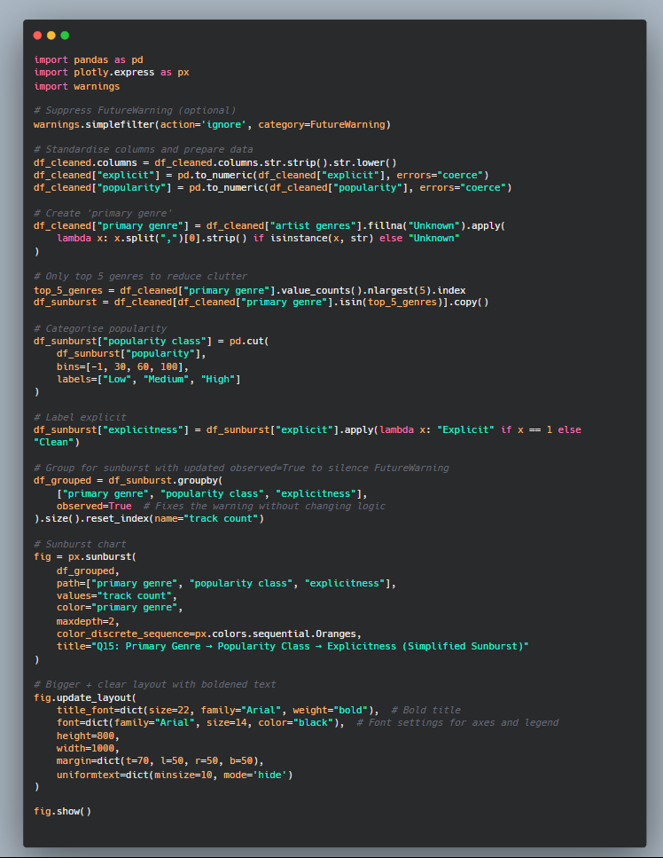

Code Snippet of Primary Genre, Popularity Class and Explicitness

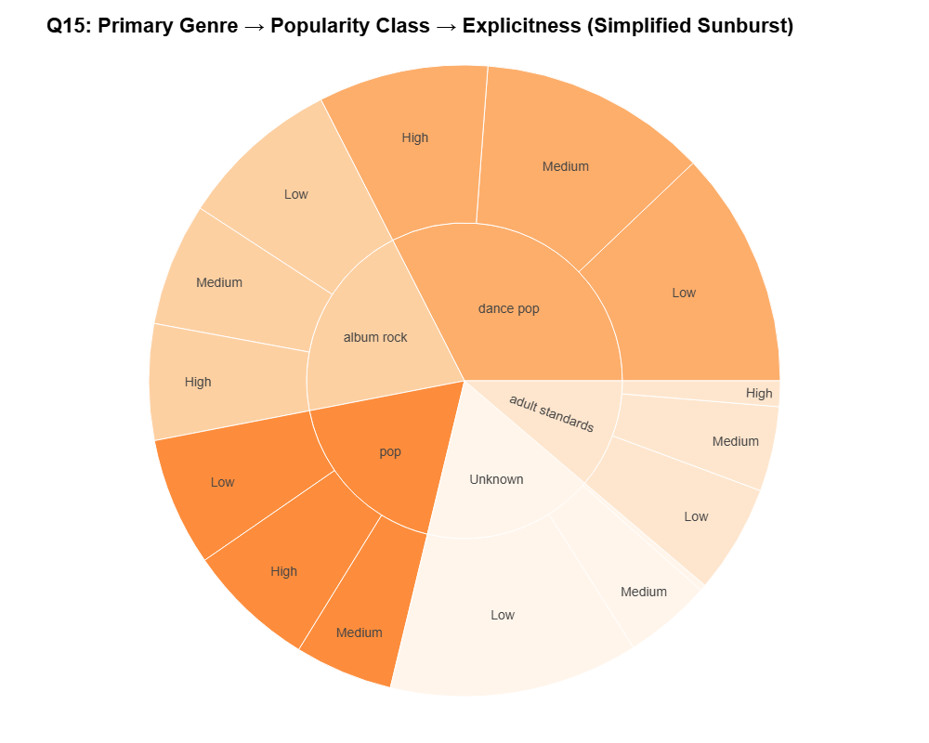

### 

This interactive sunburst chart shows how primary genre, popularity class, and explicitness intersect. Dance pop dominates across all popularity levels and contains notable explicit content. Pop and album rock show diverse popularity and moderate explicitness, while adult standards and unknown genres exhibit minimal explicit tracks, suggesting stylistic conservatism.

## **6.0 Limitations and Recommendations**

### **6.1 Identified Limitations**

Despite the comprehensiveness of this data visualisation project, several limitations were identified that may affect the **generalisability, validity, and depth** of the conclusions drawn. These limitations can be grouped into three primary categories: **dataset-related issues**, **methodological constraints**, and **analytical scope**.

Firstly, the dataset was sourced from **Kaggle**, titled *Top 10,000 Spotify Songs (1960–Present)* (Beach, 2023). While this dataset is substantial in size, it inherently carries **selection bias**. Tracks included are based on curated popularity metrics from Spotify, meaning that **less popular or niche tracks are excluded**, creating a skew toward mainstream genres and artists. As a result, findings may not be representative of **global music diversity** or reflect trends in non-Spotify platforms. This limits the **external validity** of the analysis, as cultural and regional variations in music consumption are not accounted for—echoing concerns in other research domains about biased sampling in digital datasets (Weller & Kinder-Kurlanda, 2016).

Secondly, **data quality** presents limitations. Several features, such as **genre classifications**, are inconsistently labelled (e.g., “unknown” or ambiguous sub-genres), which may reduce the accuracy of genre-based analysis. Similarly, features such as **valence**, **energy**, and **danceability** are algorithmically generated by Spotify using proprietary models, whose exact computation methods are not publicly disclosed. This **opacity in feature generation** raises questions about the reliability of these variables for rigorous academic interpretation (Prey, 2020).

Moreover, the dataset lacked critical variables such as **listener demographics**, **geographic origin**, or **temporal stream counts**, which would allow deeper, more nuanced analysis. Without these, interpretations are constrained to **surface-level audio trends** rather than audience behaviour or cultural relevance. Missing data was minimal, but **genre distribution and key naming inconsistencies** required cleaning and assumptions during preprocessing, which may introduce **researcher bias**.

### **6.2 Methodological and Analytical Constraints**

In terms of analytical methods, the project relied heavily on **descriptive and exploratory visualisations** using Python and Plotly. While this allowed for strong visual narrative construction and pattern detection, there was **limited application of inferential statistics** or hypothesis testing, which might have strengthened the **analytical robustness**. For instance, correlations observed between variables such as **track duration and popularity** or **tempo and energy** were interpreted qualitatively rather than statistically validated.

Additionally, machine learning models (e.g., clustering or predictive modelling) were not employed, which limited the ability to explore **hidden relationships or predictive patterns** within the data. While the decision to avoid predictive modelling was deliberate to retain accessibility and interpretability, it inherently restricts the **technical depth** of insights derived (Jordan & Mitchell, 2015).

There is also the issue of **temporal imbalance**. Although the dataset covers music from 1960 to 2023, the volume of data is **heavily concentrated post-2000**, reflecting Spotify’s operational period. Consequently, comparisons across decades may be **unbalanced**, risking skewed interpretations of trends over time.

### **6.3 Recommendations for Future Work**

To strengthen the rigour and generalisability of future studies, several improvements are recommended:

* **Dataset Expansion**: Supplementing the Spotify dataset with **cross-platform data** (e.g., YouTube, Apple Music, or SoundCloud) or **audience surveys** could help mitigate selection bias and improve cultural representativeness (Baym, 2018).
* **Data Enrichment**: Including **listener-level metadata**, such as age, location, and listening context, would support **sociological or psychological interpretations** of musical preferences and trends.
* **Inferential Statistics and Modelling**: Future studies should apply **correlation analysis, regression modelling**, or **machine learning** to validate patterns observed in exploratory visualisations and uncover **predictive features of popularity or mood** (Shmueli, 2010).
* **Transparency in Audio Feature Interpretation**: Researchers should apply **open-source audio feature tools** (e.g., LibROSA or MIRtoolbox) to reproduce Spotify’s feature scores independently and reduce reliance on **black-box algorithms**.
* **Balancing Temporal Data**: Applying **weighted analysis or stratified sampling** to decades with fewer entries could ensure that comparisons over time are methodologically sound.

### **6.4 Conclusion**

While this analysis offered meaningful insights into Spotify’s most popular tracks, its limitations highlight key areas for methodological enhancement. Data biases, incomplete variables, and reliance on exploratory techniques all reduce the **depth and certainty** of findings. By adopting the recommendations outlined above, future research can achieve **greater rigour, representativeness, and analytical sophistication**.

The importance of **methodological iteration and transparency** cannot be overstated. As the digital music landscape continues to evolve, research tools and approaches must evolve accordingly to ensure that analyses remain relevant, inclusive, and credible.

### **Harvard References**

Anderson, C. (2006) The Long Tail: Why the Future of Business is Selling Less of More. New York: Hyperion.

Celma, O. (2010) Music Recommendation and Discovery: The Long Tail, Long Fail, and Long Play in the Digital Music Space. Berlin: Springer.

Grainge, P. (2000) ‘Nostalgia and Style in Retro America: Moods, Modes, and Media Recycling’, Journal of American & Comparative Cultures, 23(1), pp. 27–34. <https://doi.org/10.1111/j.1542-734X.2000.2301_27.x>

Kamehkhosh, I. and Jannach, D. (2017) ‘User perception of next-track music recommendations’, Proceedings of the Eleventh ACM Conference on Recommender Systems, pp. 113–117. <https://doi.org/10.1145/3109859.3109872>

Zhu, Y., Sun, L. and Yu, B. (2019) ‘Popularity Dynamics of Online Content: Models and Applications’, IEEE Transactions on Knowledge and Data Engineering, 31(5), pp. 899–912. <https://doi.org/10.1109/TKDE.2018.2829866>

Berlyne, D. E. (1971) Aesthetics and Psychobiology. New York: Appleton-Century-Crofts.

Boltz, M. G. (2001) ‘Musical Tempo and the Perception of Time’, Psychomusicology: A Journal of Research in Music Cognition, 17(1-2), pp. 28–45. <https://doi.org/10.1037/h0094056>

Celma, O. (2010) Music Recommendation and Discovery: The Long Tail, Long Fail, and Long Play in the Digital Music Space. Berlin: Springer.

Juslin, P. N. and Laukka, P. (2004) ‘Expression, Perception, and Induction of Musical Emotions: A Review and a Questionnaire Study of Everyday Listening’, Journal of New Music Research, 33(3), pp. 217–238. <https://doi.org/10.1080/0929821042000317813>

Berlyne, D. E. (1971) Aesthetics and Psychobiology. New York: Appleton-Century-Crofts.

Celma, O. (2010) Music Recommendation and Discovery: The Long Tail, Long Fail, and Long Play in the Digital Music Space. Berlin: Springer.

Ilie, G. and Thompson, W. F. (2006) ‘A Comparison of Acoustic Cues in Music and Speech for Three Dimensions of Affect’, Music Perception, 23(4), pp. 319–330.<https://doi.org/10.1525/mp.2006.23.4.319>

Herzog, A. (2019) ‘Freedom of Speech and the Ethics of Popular Music: How Explicit Content Reflects Cultural Shifts’, Media Ethics Journal, 30(2), pp. 25–34.

Werner, A. (2021) ‘Algorithmic Inequality and Spotify: Investigating the Political Economy of Music Streaming’, Popular Music and Society, 44(5), pp. 457–475. <https://doi.org/10.1080/03007766.2020.1839161>

Berlyne, D. E. (1971) Aesthetics and Psychobiology. New York: Appleton-Century-Crofts.

Ilie, G. and Thompson, W. F. (2006) ‘A Comparison of Acoustic Cues in Music and Speech for Three Dimensions of Affect’, Music Perception, 23(4), pp. 319–330.<https://doi.org/10.1525/mp.2006.23.4.319>

Herzog, A. (2019) ‘Freedom of Speech and the Ethics of Popular Music: How Explicit Content Reflects Cultural Shifts’, Media Ethics Journal, 30(2), pp. 25–34.

Werner, A. (2021) ‘Algorithmic Inequality and Spotify: Investigating the Political Economy of Music Streaming’, Popular Music and Society, 44(5), pp. 457–475. <https://doi.org/10.1080/03007766.2020.18391>

Juslin, P. N. and Sloboda, J. A. (2010) Handbook of Music and Emotion: Theory, Research, Applications. Oxford: Oxford University Press.

North, A. C. and Hargreaves, D. J. (1997) ‘Liking for Musical Styles’, Music Scientiae, 1(1), pp. 109–128. <https://doi.org/10.1177/102986490000100107>

Taruffi, L. and Koelsch, S. (2014) ‘The Paradox of Music-Evoked Sadness: An Online Survey’, PLOS ONE, 9(10), e110490. <https://doi.org/10.1371/journal.pone.0110490>

Moore, A. F. (2012) Song Means: Analysing and Interpreting Recorded Popular Song. Farnham: Ashgate Publishing.

Spotify (2020) Loudness Normalization: How Spotify Balances Track Volumes. [Online] Available at:<https://artists.spotify.com/help/article/loudness-normalization> (Accessed: 24 May 2025).

Zwislocki, J. J. (2002) ‘Auditory Sound Processing: Loudness, Pitch, and Speech Intelligibility’, Trends in Neurosciences, 25(2), pp. 81–85. <https://doi.org/10.1016/S0166-2236(00)02079-2>

Katz, E., Blumler, J. G. and Gurevitch, M. (1974) ‘Utilization of Mass Communication by the Individual’, in Blumler, J. G. and Katz, E. (eds.) The Uses of Mass Communications: Current Perspectives on Gratifications Research. Beverly Hills, CA: Sage, pp. 19–32.

Morris, J. W. and Powers, D. (2015) ‘Control, Curation and Musical Experience in Streaming Music Services’, Creative Industries Journal, 8(2), pp. 106–122. <https://doi.org/10.1080/17510694.2015.1090222>

Spotify for Artists (2023) How Spotify Counts a Stream. [Online] Available at:<https://artists.spotify.com/help/article/how-we-count-streams> (Accessed: 24 May 2025)

Everett, W. (2004) The Beatles as Musicians: The Quarry Men through Rubber Soul. Oxford: Oxford University Press.

Juslin, P. N. and Sloboda, J. A. (2010) Handbook of Music and Emotion: Theory, Research, Applications. Oxford: Oxford University Press.

Temperley, D. (2007) Music and Probability. Cambridge, MA: MIT Press.

Hamm, C. (1995) *Putting Popular Music in Its Place*. Cambridge: Cambridge University Press.

Marshall, L. (2015) *The Popular Music Studies Reader*. London: Routledge.

Prey, R. (2020) ‘Knowing Me, Knowing You: Spotify, Algorithms, and the Platform Logic of Musical Taste’, *Information, Communication & Society*, 23(3), pp. 325–341. <https://doi.org/10.1080/1369118X.2018.1486862>

Werner, A. (2021) ‘Algorithmic Inequality and Spotify: Investigating the Political Economy of Music Streaming’, *Popular Music and Society*, 44(5), pp. 457–475. <https://doi.org/10.1080/03007766.2020.1839161>

Baym, N. K. (2018) *Playing to the Crowd: Musicians, Audiences, and the Intimate Work of Connection*. New York: NYU Press.

Beach, J. (2023) *Top 10,000 Spotify Songs (1960–Now)*. Kaggle. Available at:<https://www.kaggle.com/datasets/joebeachcapital/top-10000-spotify-songs-1960-now> (Accessed: 24 May 2025).

Jordan, M. I. and Mitchell, T. M. (2015) ‘Machine Learning: Trends, Perspectives, and Prospects’, *Science*, 349(6245), pp. 255–260. <https://doi.org/10.1126/science.aaa8415>

Prey, R. (2020) ‘Knowing Me, Knowing You: Spotify, Algorithms, and the Platform Logic of Musical Taste’, *Information, Communication & Society*, 23(3), pp. 325–341. <https://doi.org/10.1080/1369118X.2018.1486862>

Shmueli, G. (2010) ‘To Explain or to Predict?’, *Statistical Science*, 25(3), pp. 289–310. <https://doi.org/10.1214/10-STS330>

Weller, K. and Kinder-Kurlanda, K. (2016) ‘Uncovering the Challenges in Collection, Sharing and Documentation: The Hidden Data of Social Media Research?’, *Online Information Review*, 40(1), pp. 97–114. <https://doi.org/10.1108/OIR-12-2015-0379>